# VISVESVARAYATECHNOLOGICAL UNIVERSITY

**“JnanaSangama”, Belgaum -590014, Karnataka.**



## LAB REPORT

### on

ObjectOrientedJavaProgramming (23CS3PCOOJ)

#### Submitted by

**ABDUL AHAD (1BM23AI002)**

#### in partial fulfillment for the award of the degree of

**BACHELOR OF ENGINEERING**

***in***

## COMPUTER SCIENCE AND ENGINEERING

**B.M.S. COLLEGE OF ENGINEERING**

**(Autonomous Institution under VTU)**

### BENGALURU-560019 Sep-2024 TO Jan-2025

**B.M.S. College of Engineering,**

**Bull Temple Road, Bangalore 560019**

(Affiliated To Visvesvaraya Technological University, Belgaum)

**Department of Computer Science and Engineering**



##### CERTIFICATE

This is to certify that the Lab work entitled “OBJECT ORIENTED JAVA PROGRAMMING” carried out by **ABDUL AHAD(1BM23AI002)** who is bonafide student of **B.M.S. College of Engineering.** It is in partial fulfillment for the award of **Bachelor of Engineering in Computer Science and Engineering** of the Visvesvaraya Technological University, Belgaum. The Lab report has been approved as it satisfies the academic requirements in respect of an Artificial Intelligence (23CS5PCAIN) work prescribed for the said degree.

Mrs SWATHI SRIDHARAN

Department of CSE, BMSCE

Ms AMBUJA K

Assistant Professor DepartmentofCSE,BMSCE

# Index

|  |  |  |  |
| --- | --- | --- | --- |
| **Sl.**  **No.** | **Date** | **Experiment Title** |  |
| 1 | 12/11/2024 | QUADRATIC EQUATION |  |
| 2 | 19/11/2024 | SGPA CALCULATOR |  |
| 3 | 26/11/2024 | BOOKS |  |
| 4 | 26/11/2024 | AREA OF SHAPE |  |
| 5 | 3/12/2024 | BANK |  |
| 6 | 3/12/2024 | PACKAGE CIE SEE |  |
| 7 | 10/12/2024 | FATHER SON AGE EXCEPTION |  |
| 8 | 15/12/2024 | MULTI THREADING |  |
| 9 | 15/12/2024 | INTEGER DIVISION |  |
| 10 | 15/12/2024 | OPEN ENDED –DEADLOCK IPC |  |

Github Link: https://github.com/Abdul31347/OOJ-3SEM/tree/main/lab

##### Program 1

Code:

import java.util.Scanner;

public class lab1{

public static void main(String[] args) {

Scanner sc = new Scanner(System.in);

System.out.print("Enter coefficient a: ");

double a = sc.nextDouble();

System.out.print("Enter coefficient b: ");

double b = sc.nextDouble();

System.out.print("Enter coefficient c: ");

double c = sc.nextDouble();

double discriminant = b * b - 4 * a * c;

if (discriminant < 0) {

System.out.println("The equation has no real solutions.");

} else if (discriminant == 0) {

double root = -b / (2 * a);

System.out.println("The equation has one real solution: " + root);

} else {

double root1 = (-b + Math.sqrt(discriminant)) / (2 * a);

double root2 = (-b - Math.sqrt(discriminant)) / (2 * a);

System.out.println("The equation has two real solutions:");

System.out.println("Root 1: " + root1);

System.out.println("Root 2: " + root2);

}

}

}

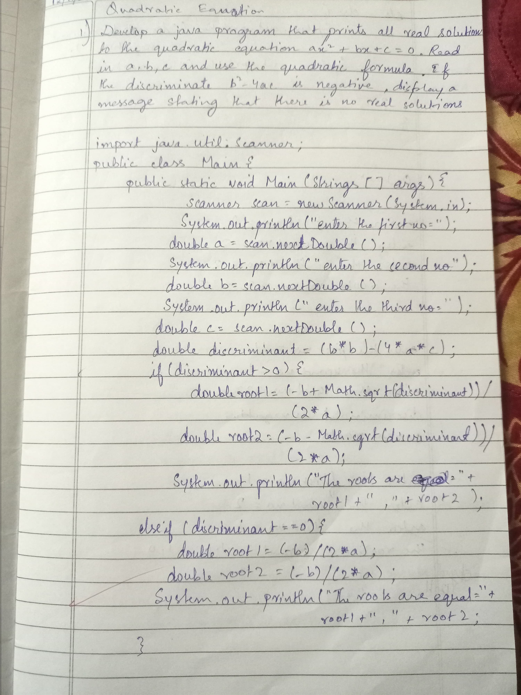

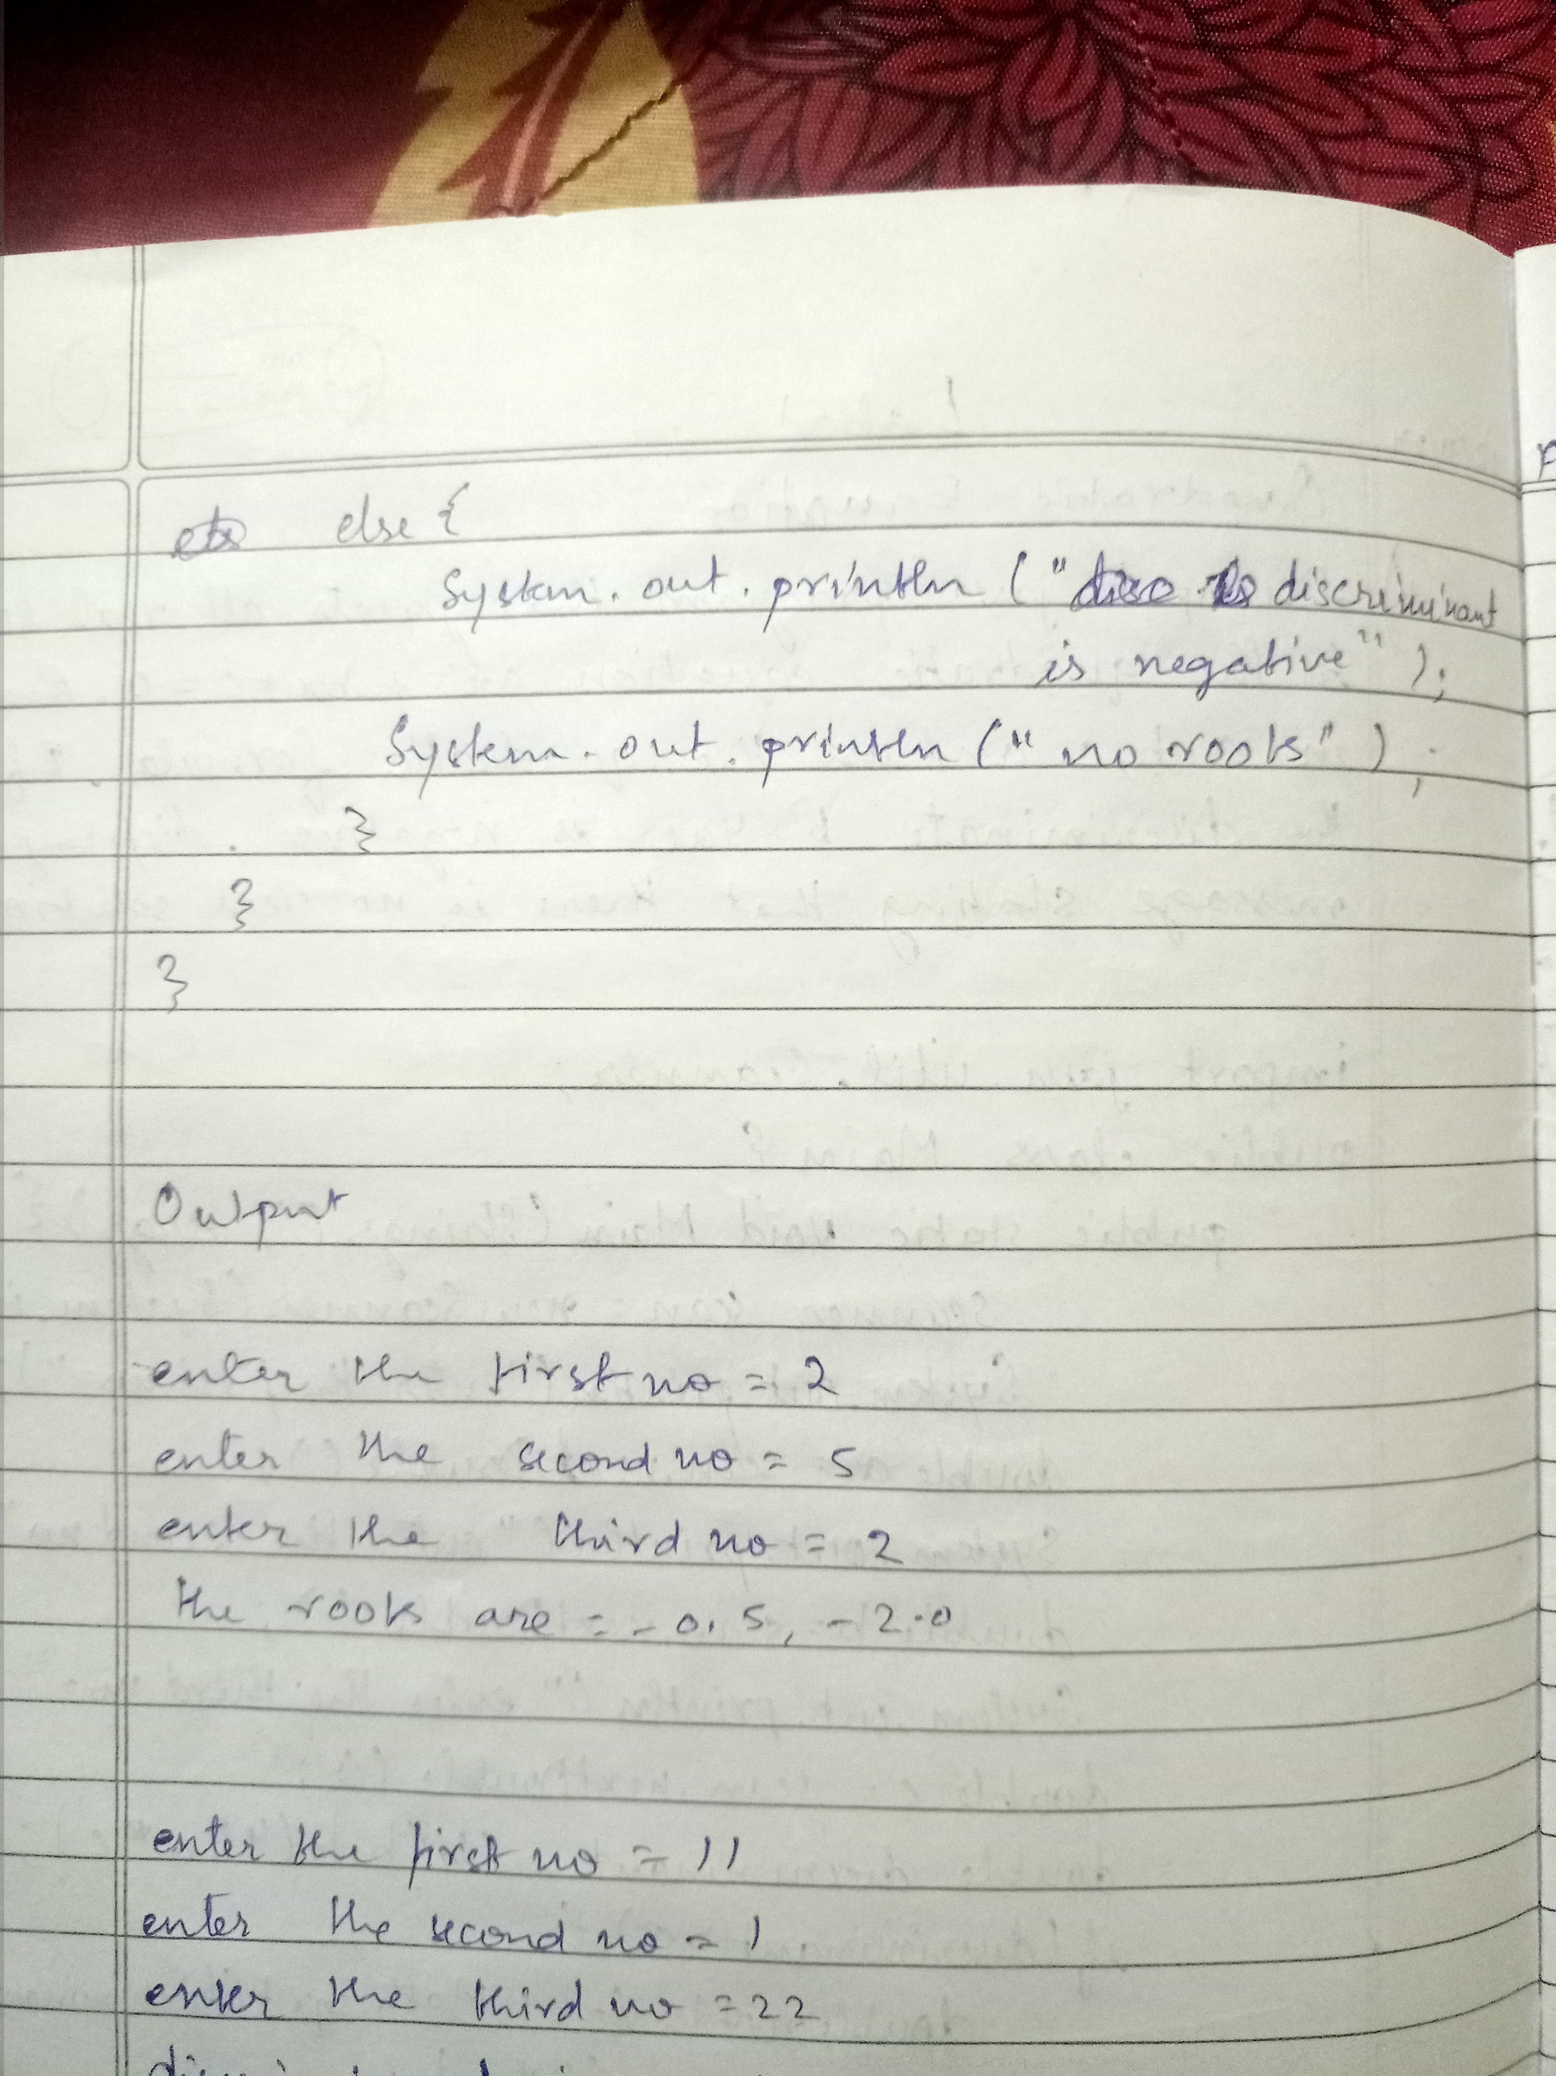

Output:

Enter coefficient a: 1

Enter coefficient b: 2

Enter coefficient c: 1

The equation has one real solution: -1.0

Enter coefficient a: 2

Enter coefficient b: 5

Enter coefficient c: 3

The equation has two real solutions:

Root 1: -1.0

Root 2: -1.5

PROGRAM 2:

import java.io.*;

import java.util.Scanner;

public class student{

Scanner sc=new Scanner(System.in);

String usn;

String name;

int [] credit;

int [] marks;

public student(int numsubjects){

credit=new int[numsubjects];

marks=new int[numsubjects];

}

void accept(){

System.out.println("enter usn=");

usn=sc.nextLine();

System.out.println("enter name=");

name=sc.nextLine();

for(int i=0;i<credit.length();i++){

System.out.printf("enter credit of subject%d=",i);

credit[i]=sc.nextLine();

}

for(int j=0;j<marks.length();j++){

System.out.printf("enter marks of subject%d=",i);

marks[i]=sc.nextLine();

}

}

void display(){

System.out.println("usn="+usn);

System.out.println("name="+name);

for(int i=0;i<credit.length();i++){

System.out.printf("credit of subject%d=%d",i,credit[i]);

}

for(int j=0;j<marks.length();j++){

System.out.printf("marks of subject%d=",i,marks[j]);

}

}

void calc(){

int totalcredit=0;

int wmarks;

for(int i=0;i<credit.length();i++){

int mmars=(marks[i]/10)+1;

totalcredit=totalcredit+credit[i];

wmarks=wmarks+mmarks*credit[i];

}

if(totalcredit==0){

return 0;

}

System.out.println("gpa="+(wmarks/totalcredit));

}

public static void main(String[] args){

int numsubjects=sc.nextInt();

student s1=new student(numsubjects);

s1.accept();

s1.display();

s1.calc();

}

}

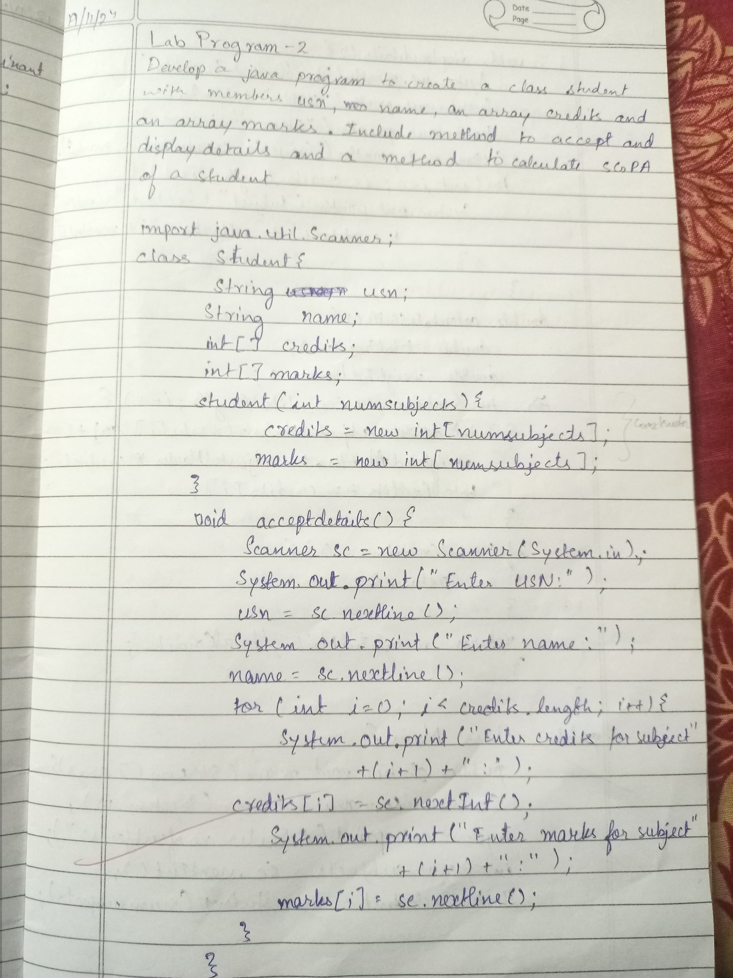

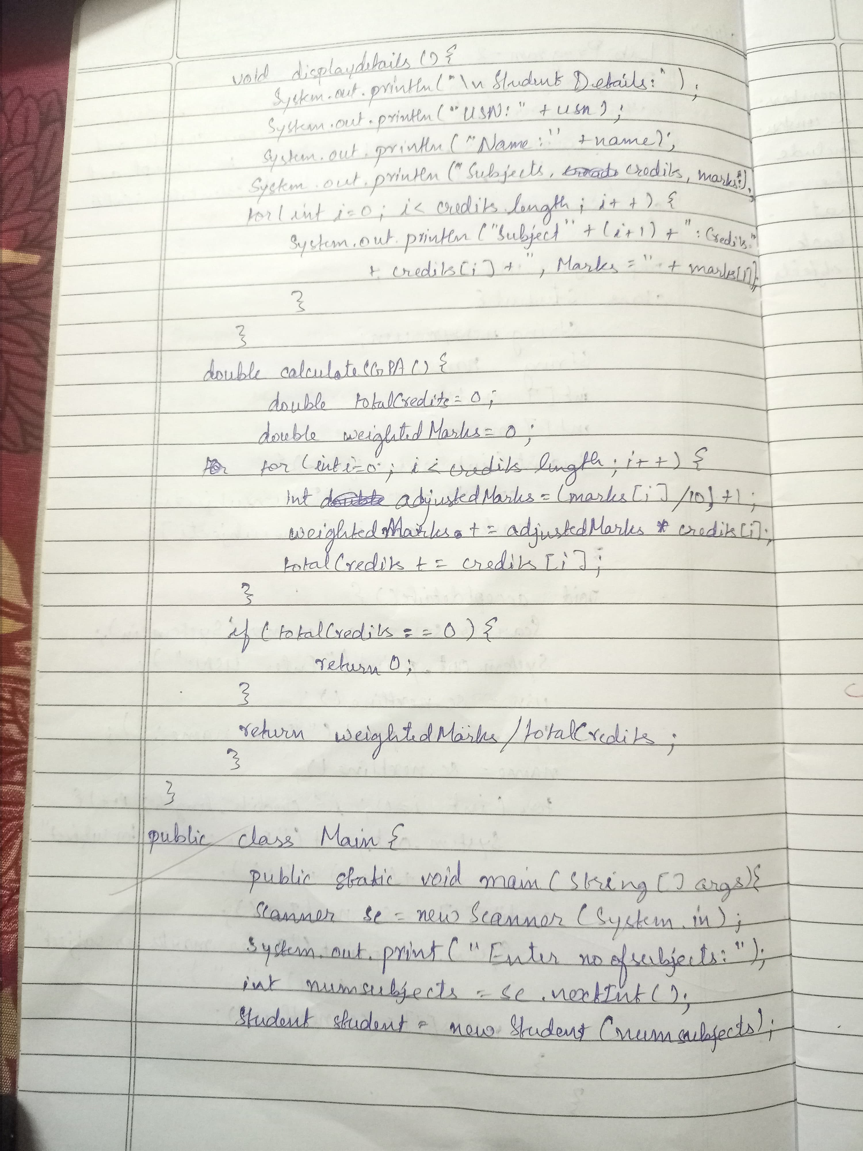

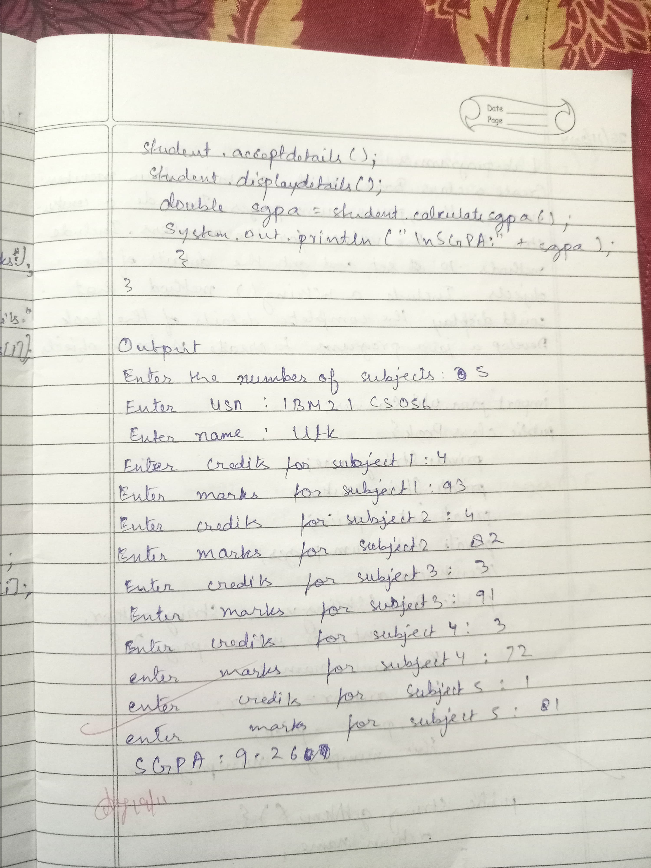

OUTPUT:

Enter the number of subjects: 3

Enter USN: 1BM21CS056

Enter Name: UTK

Enter credit of subject 1: 4

Enter credit of subject 2: 3

Enter credit of subject 3: 2

Enter marks of subject 1: 85

Enter marks of subject 2: 90

Enter marks of subject 3: 75

USN: 1BM21CS056

Name: UTK

Credit of subject 1: 4

Credit of subject 2: 3

Credit of subject 3: 2

Marks of subject 1: 85

Marks of subject 2: 90

Marks of subject 3: 75

GPA: 8.44

PROGRAM 3

import java.util.Scanner;

class Book {

private String name;

private String author;

private double price;

private int numPages;

public Book(String name, String author, double price, int numPages) {

this.name = name;

this.author = author;

this.price = price;

this.numPages = numPages;

}

public String getName() {

return name;

}

public void setName(String name) {

this.name = name;

}

public String getAuthor() {

return author;

}

public void setAuthor(String author) {

this.author = author;

}

public double getPrice() {

return price;

}

public void setPrice(double price) {

this.price = price;

}

public int getNumPages() {

return numPages;

}

public void setNumPages(int numPages) {

this.numPages = numPages;

}

@Override

public String toString() {

return "Book Name: " + name + "\n" +

"Author: " + author + "\n" +

"Price: $" + price + "\n" +

"Number of Pages: " + numPages;

}

}

public class BookManager {

public static void main(String[] args) {

Scanner sc = new Scanner(System.in);

System.out.print("Enter the number of books: ");

int n = sc.nextInt();

sc.nextLine();

Book[] books = new Book[n];

for (int i = 0; i < n; i++) {

System.out.println("Enter details for Book " + (i + 1) + ":");

System.out.print("Enter book name: ");

String name = sc.nextLine();

System.out.print("Enter author name: ");

String author = sc.nextLine();

System.out.print("Enter price: ");

double price = sc.nextDouble();

System.out.print("Enter number of pages: ");

int numPages = sc.nextInt();

sc.nextLine();

books[i] = new Book(name, author, price, numPages);

}

System.out.println("\nDetails of all books:");

for (int i = 0; i < n; i++) {

System.out.println("\nBook " + (i + 1) + ":");

System.out.println(books[i].toString());

}

}

}

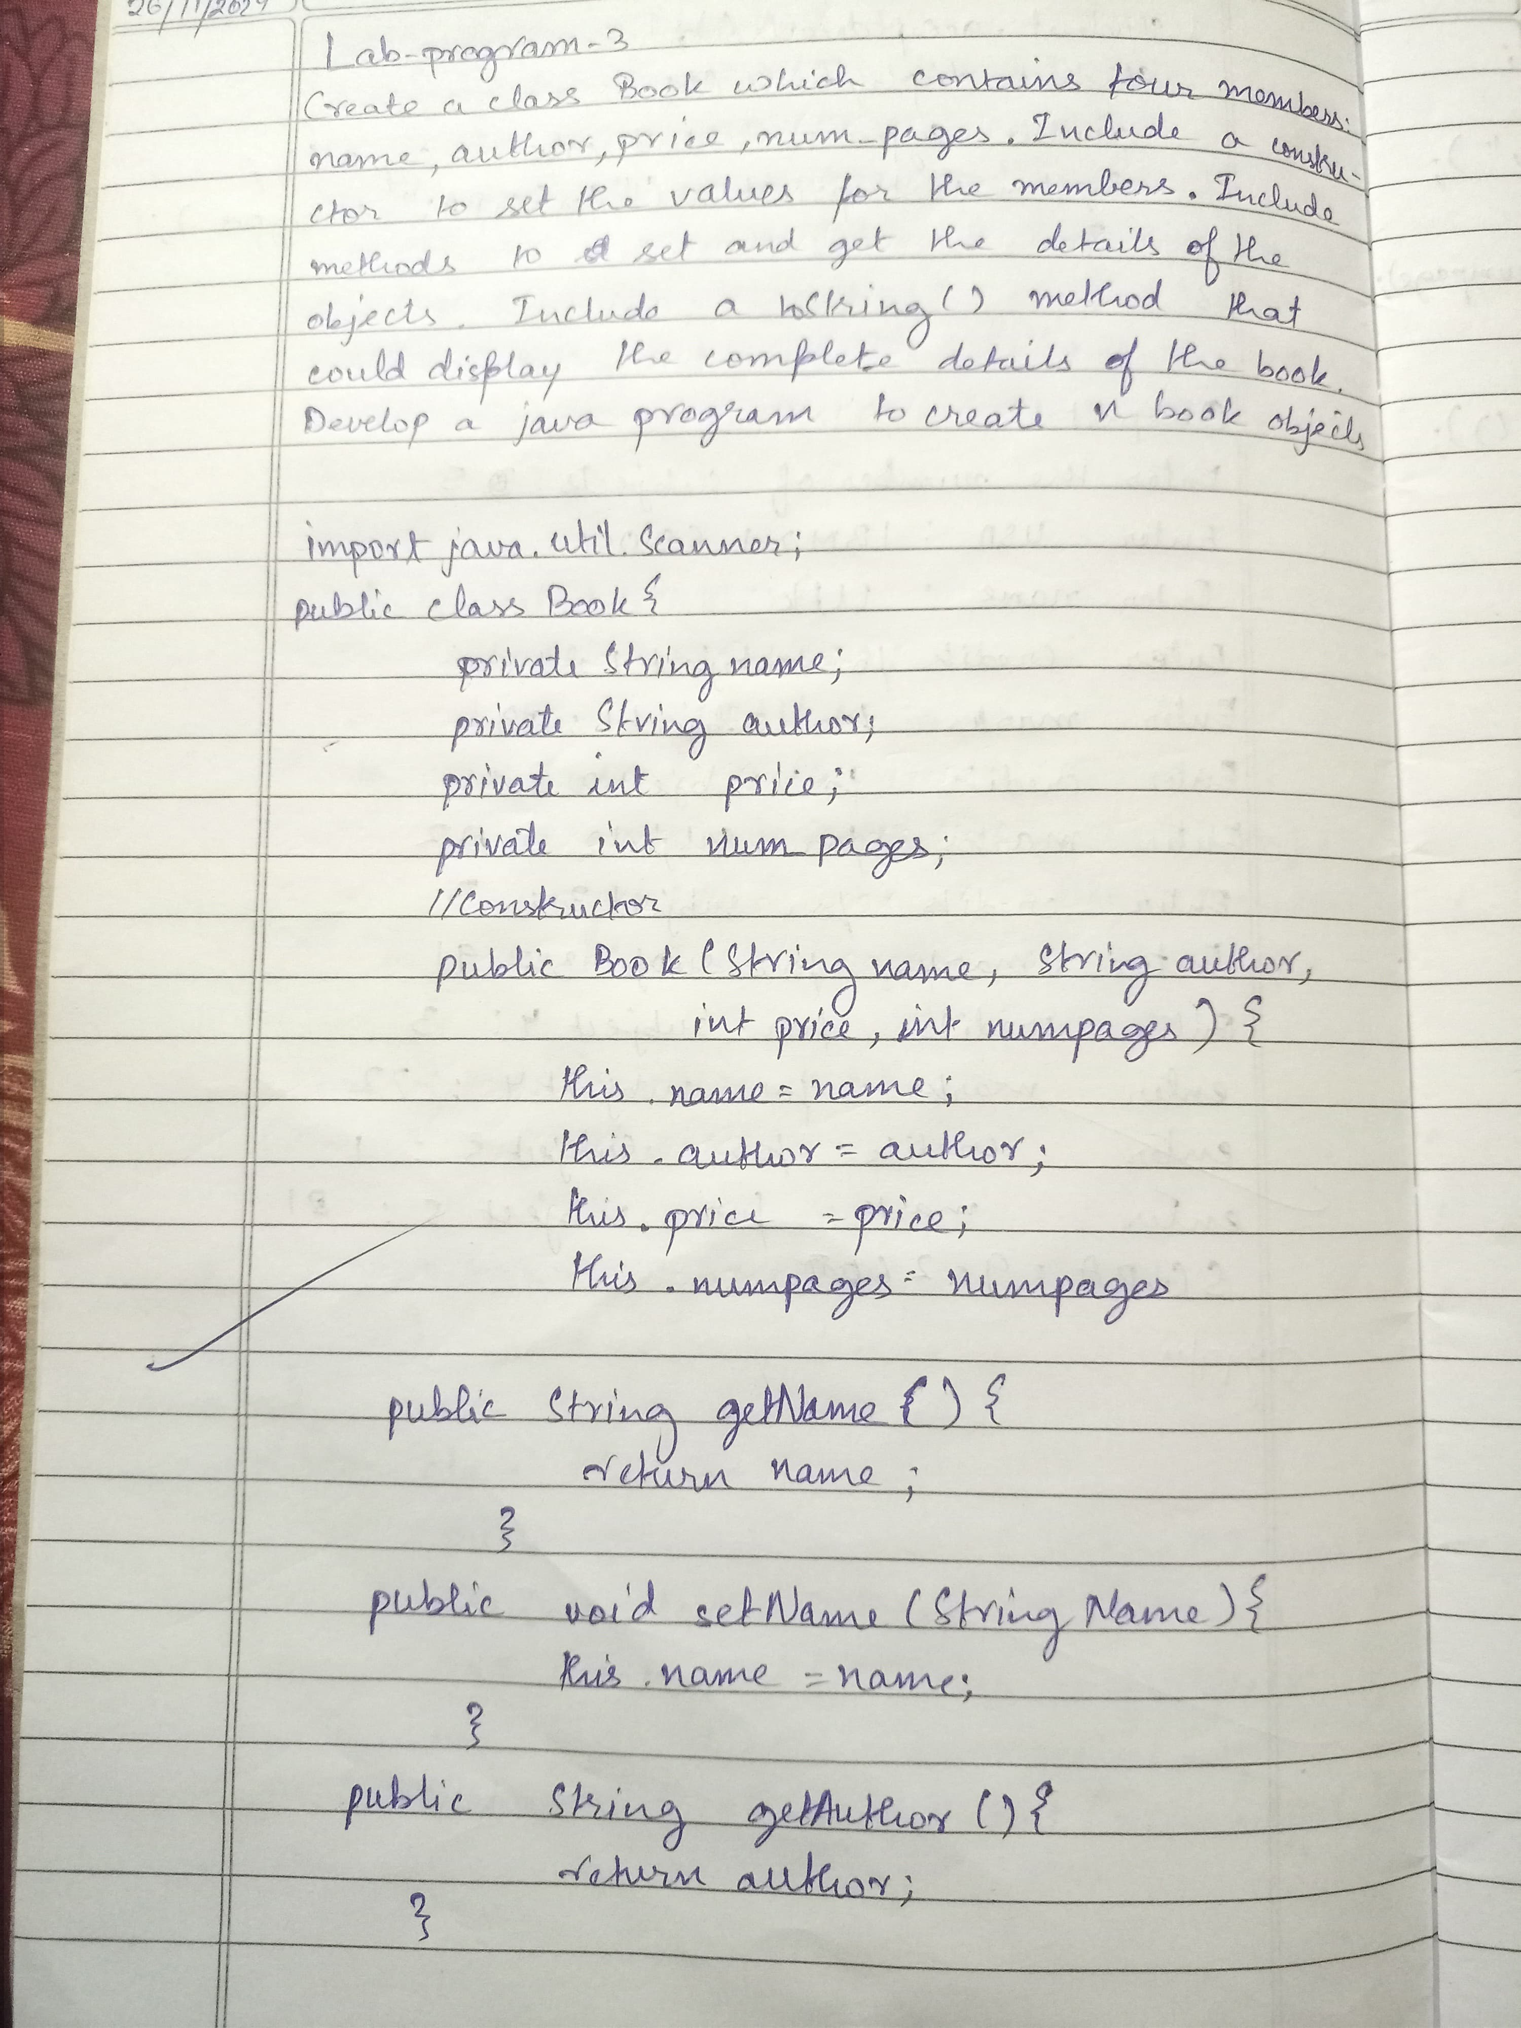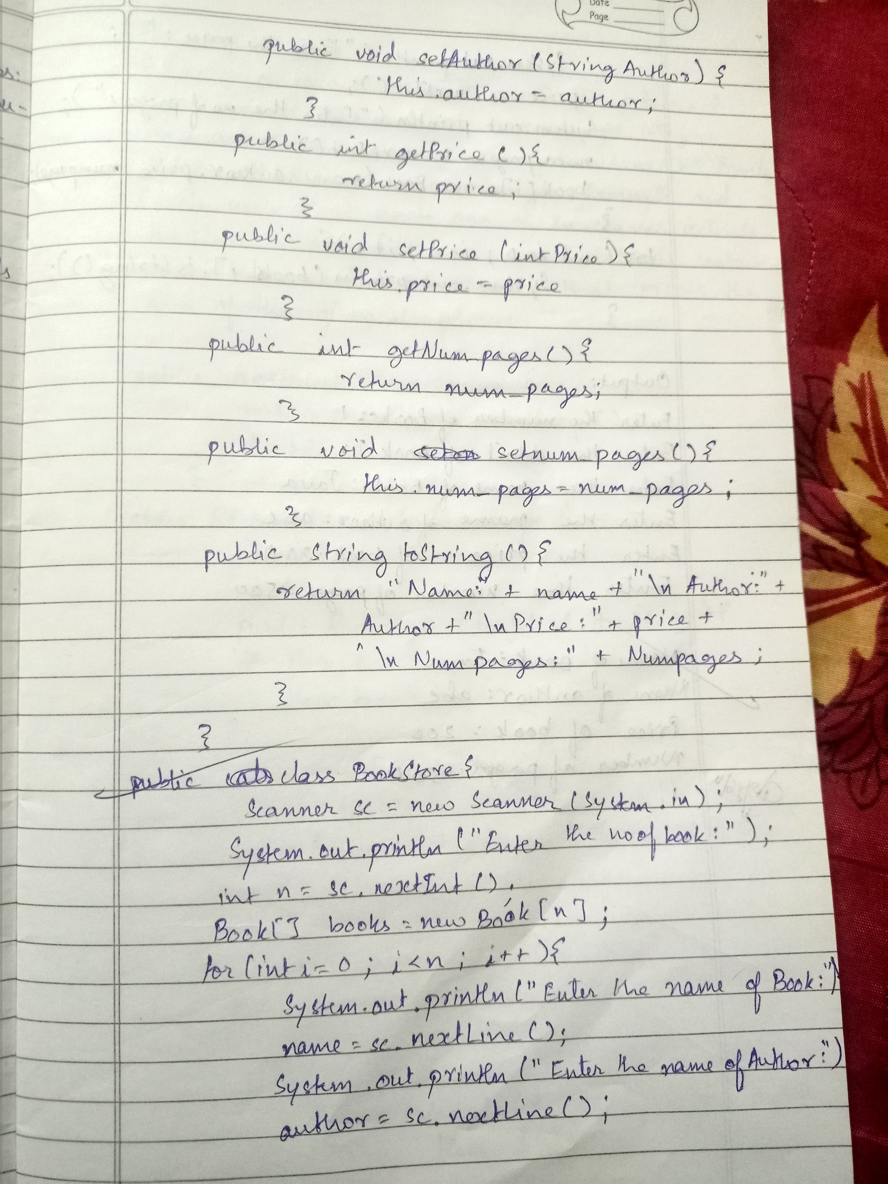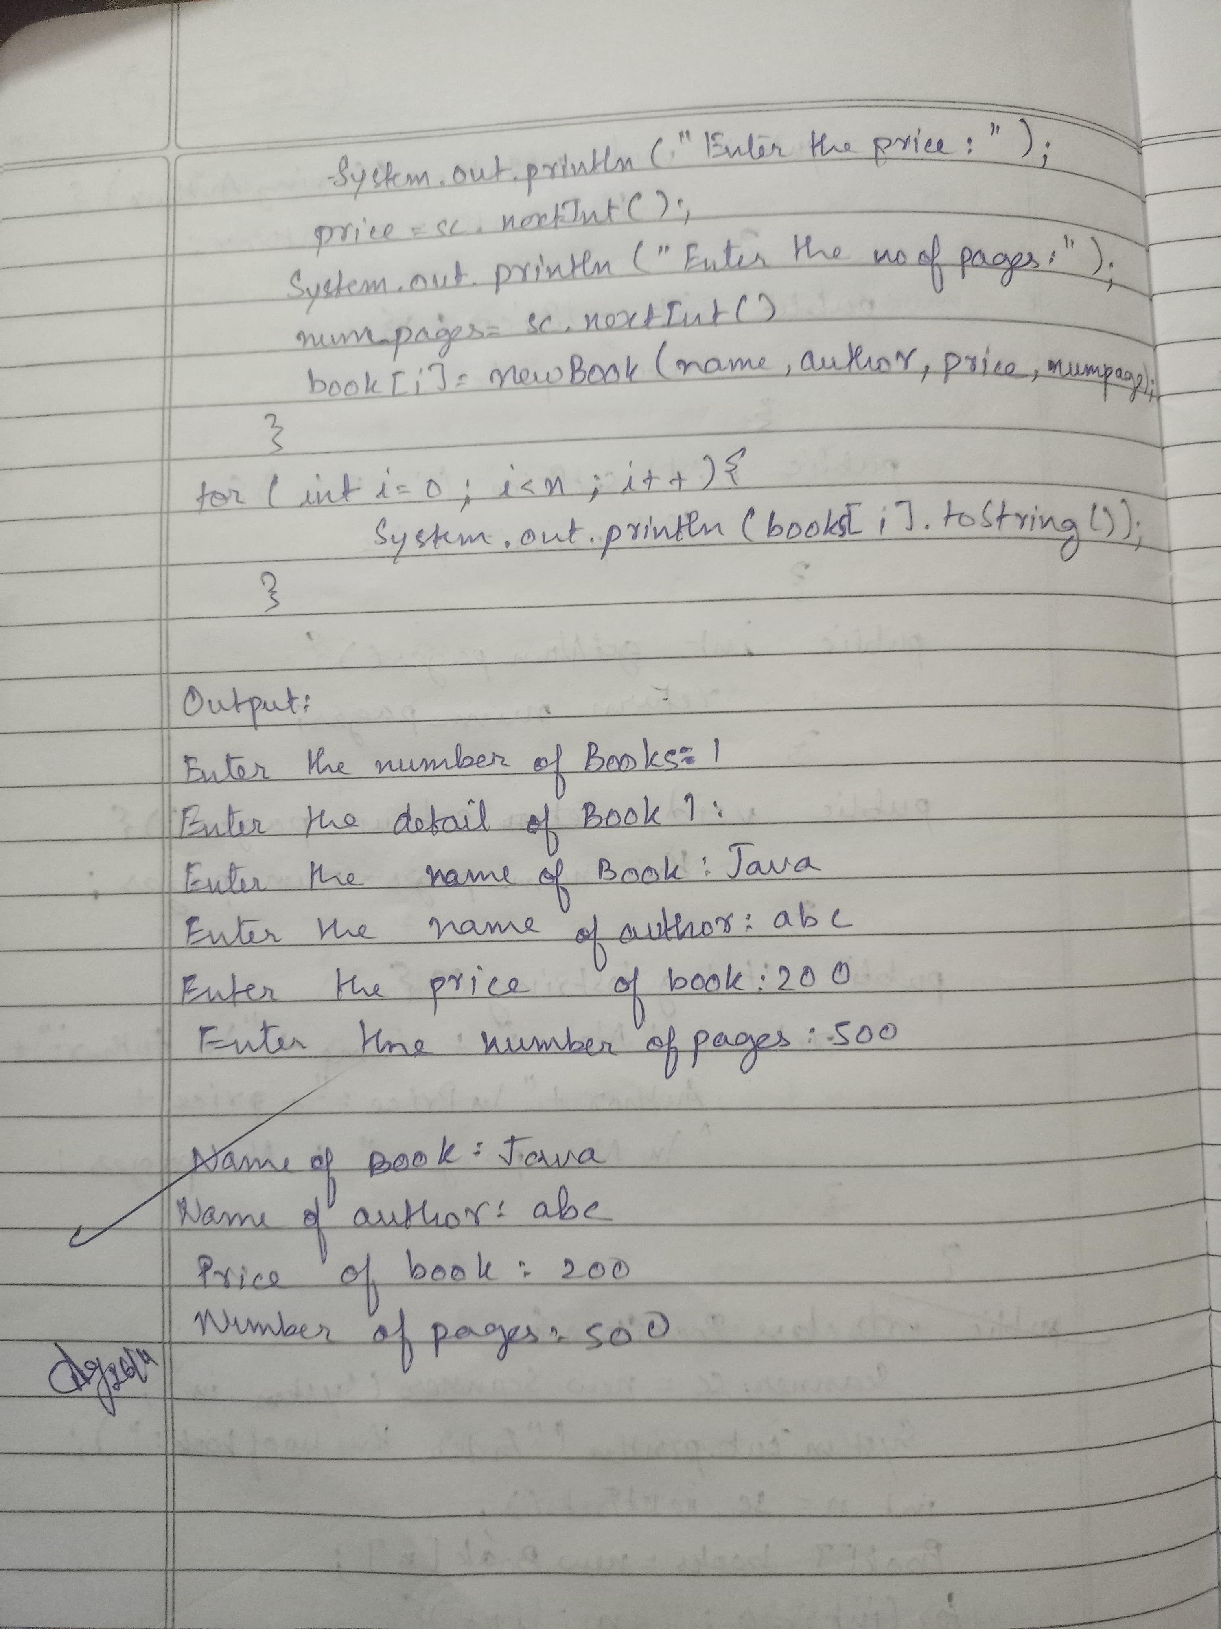

OUTPUT:

Enter the number of books: 2

Enter details for Book 1:

Enter book name: Java Programming

Enter author name: John Doe

Enter price: 49.99

Enter number of pages: 350

Enter details for Book 2:

Enter book name: Data Structures

Enter author name: Jane Smith

Enter price: 39.50

Enter number of pages: 420

Details of all books:

Book 1:

Book Name: Java Programming

Author: John Doe

Price: $49.99

Number of Pages: 350

Book 2:

Book Name: Data Structures

Author: Jane Smith

Price: $39.5

Number of Pages: 420

PROGRAM 4

import java.util.Scanner;

abstract class Shape {

int l,b,r;

abstract void printArea();

}

class Rectangle extends Shape {

Rectangle(int length, int breadth) {

this.l = length;

this.b = breadth;

}

void printArea() {

System.out.println("Area of Rectangle: " + l* b);

}

}

class Triangle extends Shape {

Triangle(int base, int height) {

this.l = base;

this.b = height;

}

void printArea() {

System.out.println("Area of Triangle: " + (0.5 * l * b));

}

}

class Circle extends Shape {

Circle(int radius) {

this.r = radius;

}

void printArea() {

System.out.println("Area of Circle: " + (Math.PI * l * l));

}

}

public class area{

public static void main(String[] args) {

Rectangle r1=new Rectangle(10,20);

r1.printArea();

Triangle t1=new Triangle(10,20);

t1.printArea();

Circle c1=new Circle(20);

c1.printArea();

}

}

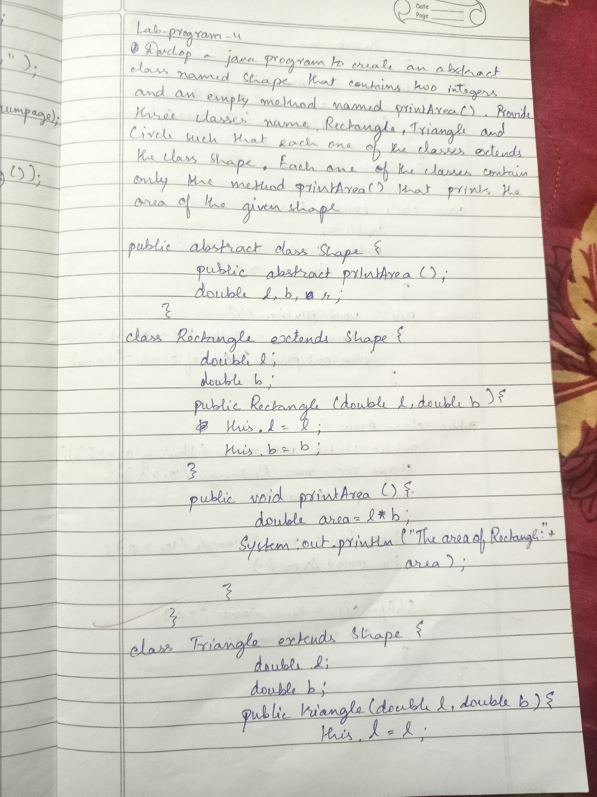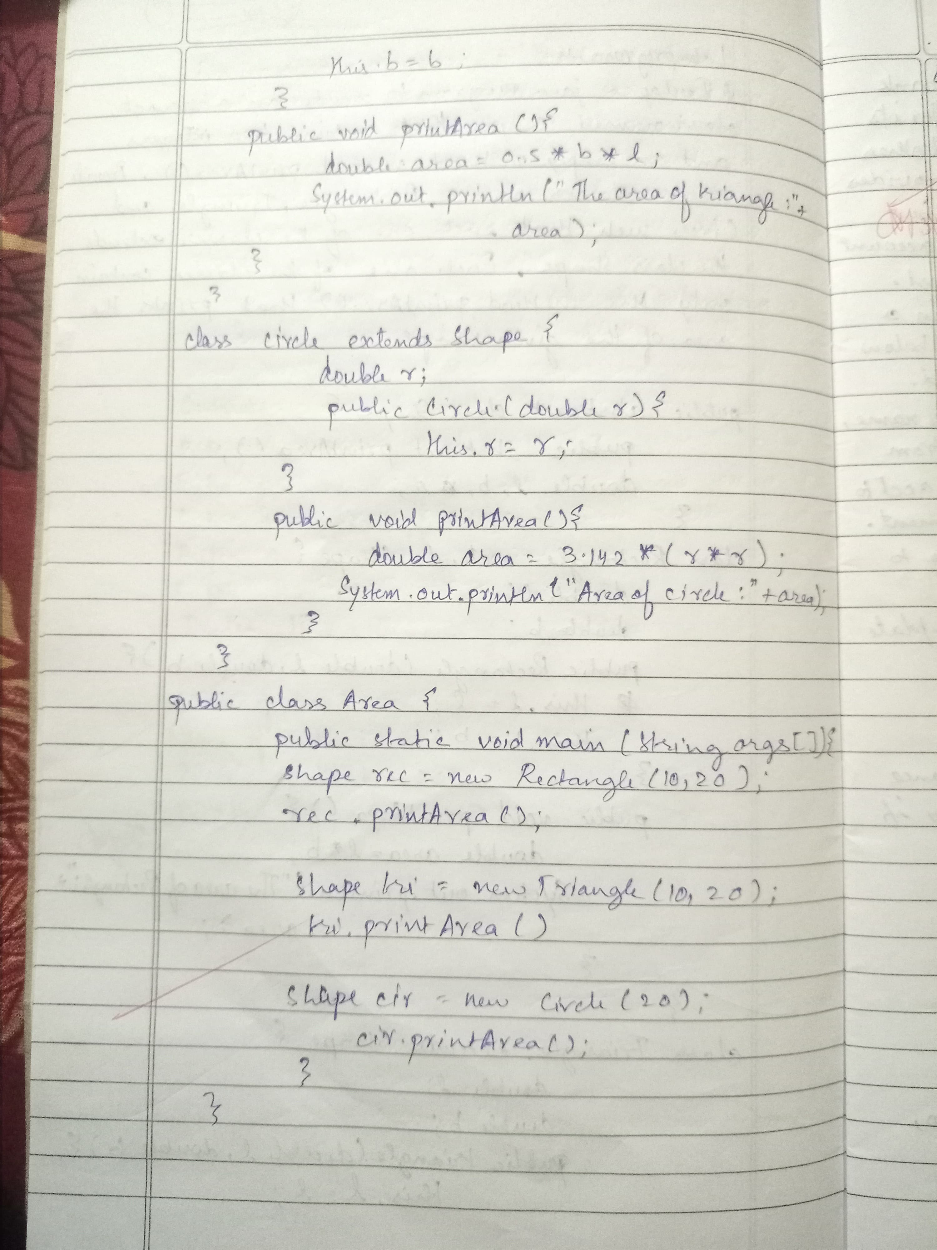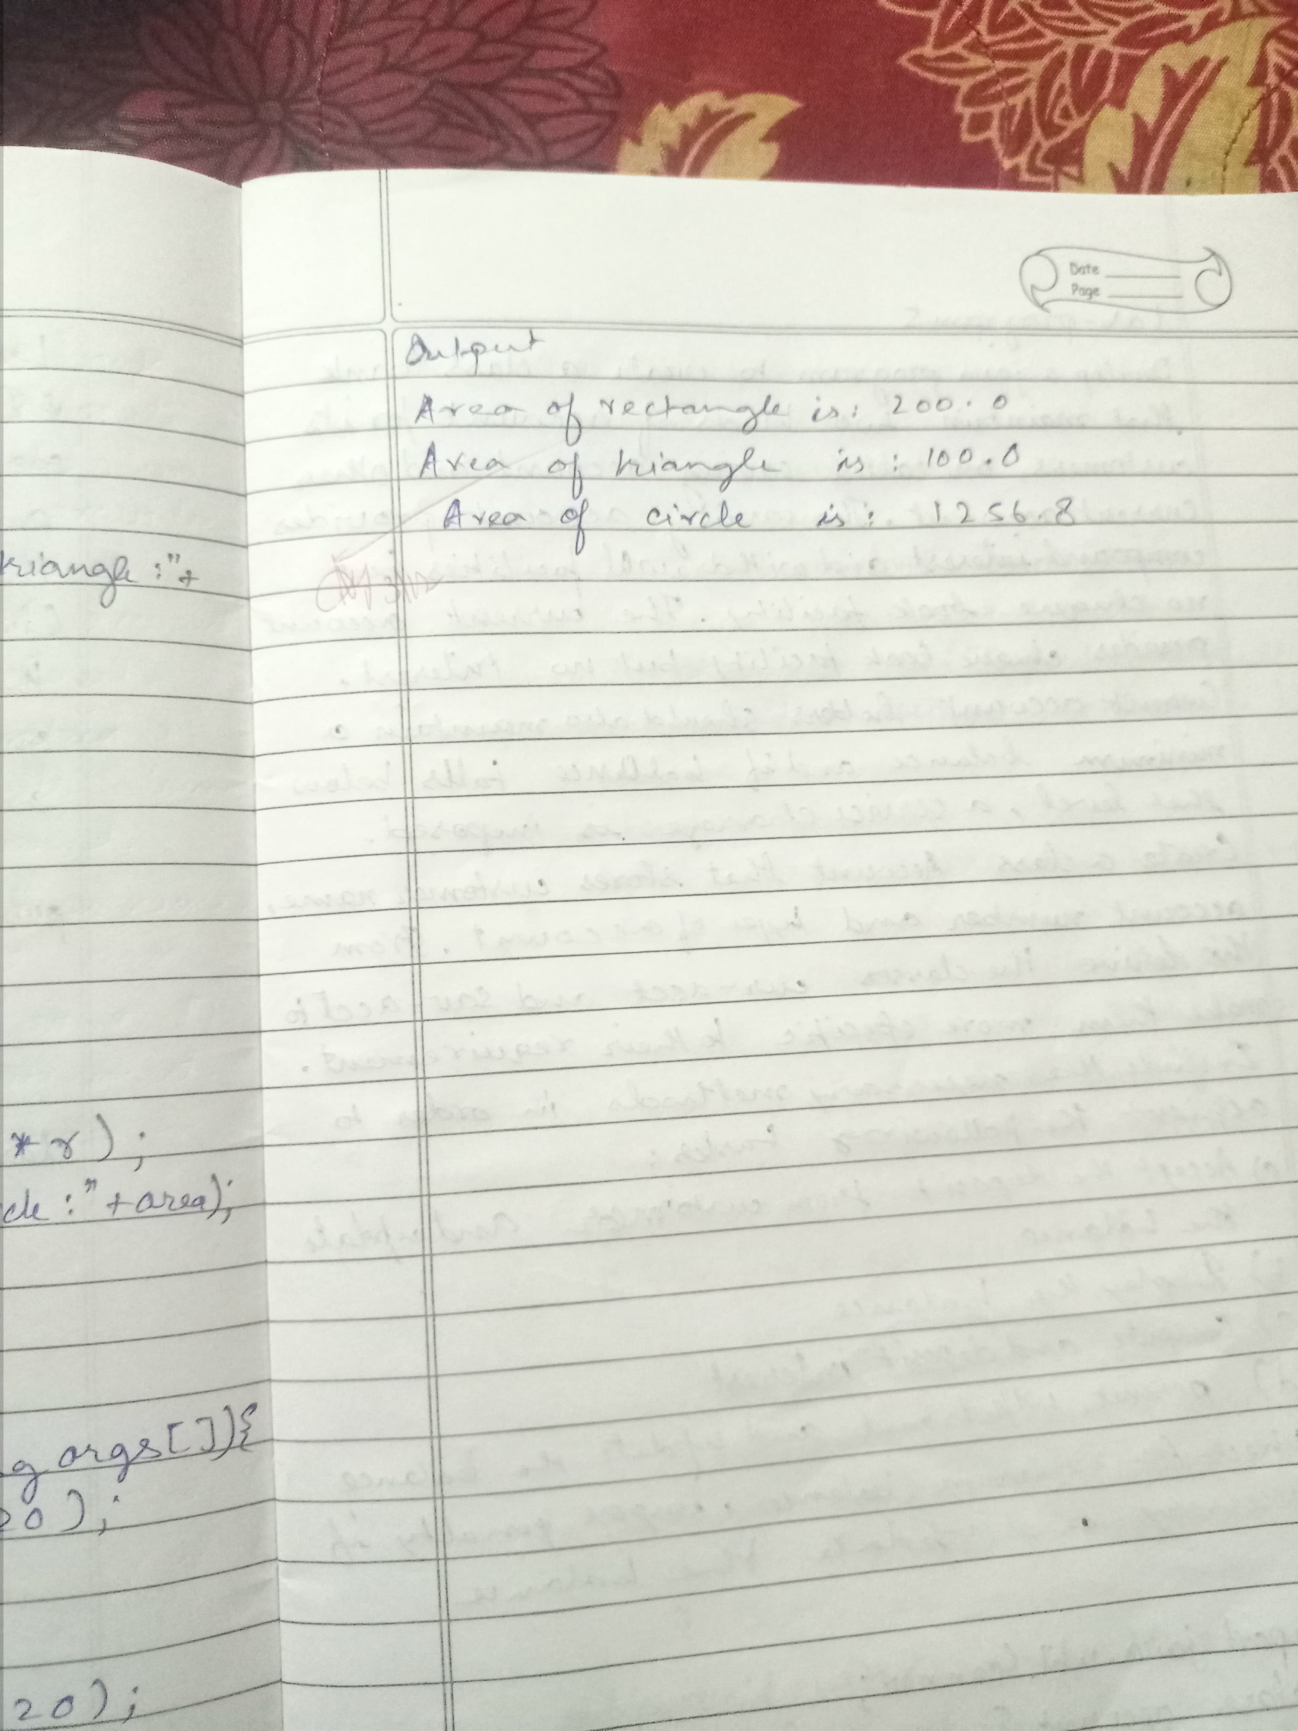

OUTPUT:

Area of Rectangle: 200

Area of Triangle: 100.0

Area of Circle: 1256.63

PROGRAM 5

import java.util.Scanner;

class Account {

String name;

int accNo;

double balance;

public Account(String name, int accNo, double balance) {

this.name = name;

this.accNo = accNo;

this.balance = balance;

}

public void deposit(double amount) {

balance += amount;

System.out.println("Deposit successful! Current balance = " + balance);

}

public void display() {

System.out.println("Current balance = " + balance);

}

}

class SavAccount extends Account {

public SavAccount(String name, int accNo, double balance) {

super(name, accNo, balance);

}

public void calculateInterest() {

double rate = 0.05;

double interest = rate * balance;

balance += interest;

System.out.println("Interest applied! Current balance = " + balance);

}

public void withdraw(double amount) {

if (amount <= balance) {

balance -= amount;

System.out.println("Withdrawal successful! Current balance = " + balance);

} else {

System.out.println("Insufficient balance.");

}

}

}

class CurAccount extends Account {

int minBalance = 1000;

int penalty = 50;

public CurAccount(String name, int accNo, double balance) {

super(name, accNo, balance);

}

public void withdraw(double amount) {

if (balance - amount >= minBalance) {

balance -= amount;

System.out.println("Withdrawal successful! Current balance = " + balance);

} else {

balance -= penalty;

System.out.println("Penalty applied! Current balance = " + balance);

}

}

}

public class Bank {

public static void main(String[] args) {

Scanner sc = new Scanner(System.in);

SavAccount sav = new SavAccount("Abe", 203, 1000);

CurAccount cur = new CurAccount("Abc", 204, 2000);

int choice;

while (true) {

System.out.println("Press 1 for Savings Account, 2 for Current Account, 0 to Exit:");

choice = sc.nextInt();

if (choice == 1) {

System.out.println("1 - Display Balance\n2 - Withdraw\n3 - Deposit\n4 - Calculate Interest");

int option = sc.nextInt();

if (option == 1) {

sav.display();

} else if (option == 2) {

System.out.print("Enter amount to withdraw: ");

double amount = sc.nextDouble();

sav.withdraw(amount);

} else if (option == 3) {

System.out.print("Enter amount to deposit: ");

double amount = sc.nextDouble();

sav.deposit(amount);

} else if (option == 4) {

sav.calculateInterest();

} else {

System.out.println("Invalid option.");

}

} else if (choice == 2) {

System.out.println("1 - Display Balance\n2 - Withdraw\n3 - Deposit");

int option = sc.nextInt();

if (option == 1) {

cur.display();

} else if (option == 2) {

System.out.print("Enter amount to withdraw: ");

double amount = sc.nextDouble();

cur.withdraw(amount);

} else if (option == 3) {

System.out.print("Enter amount to deposit: ");

double amount = sc.nextDouble();

cur.deposit(amount);

} else {

System.out.println("Invalid option.");

}

} else if (choice == 0) {

System.out.println("Exiting program.");

break;

} else {

System.out.println("Invalid choice.");

}

}

}

}

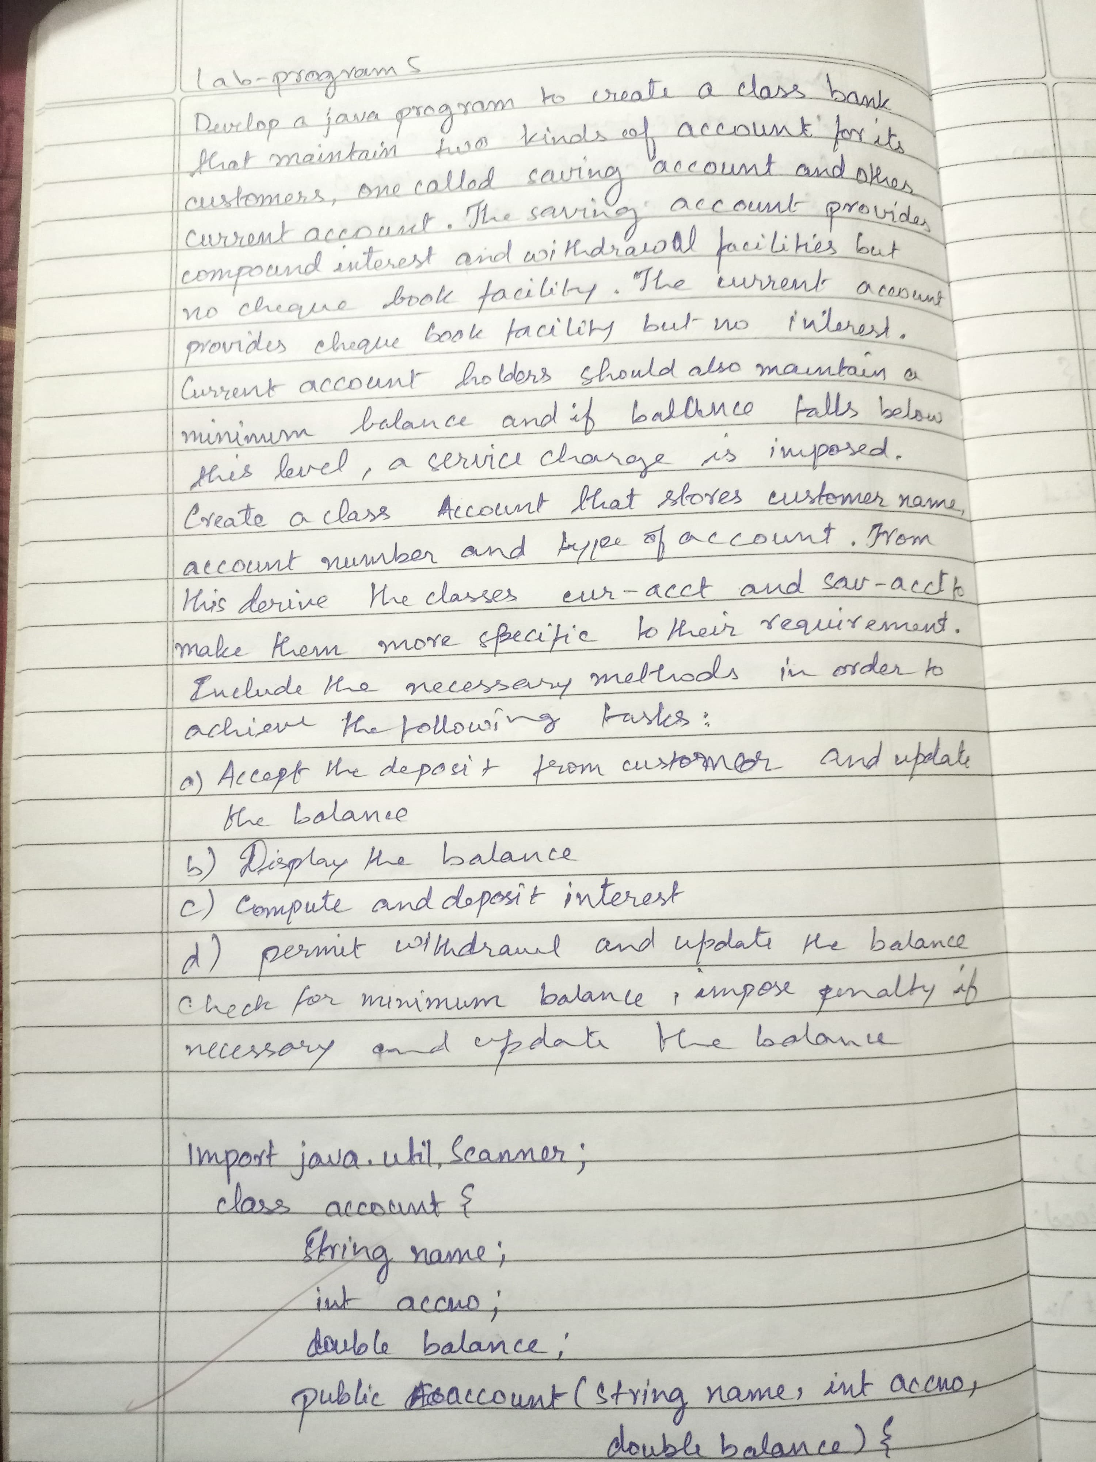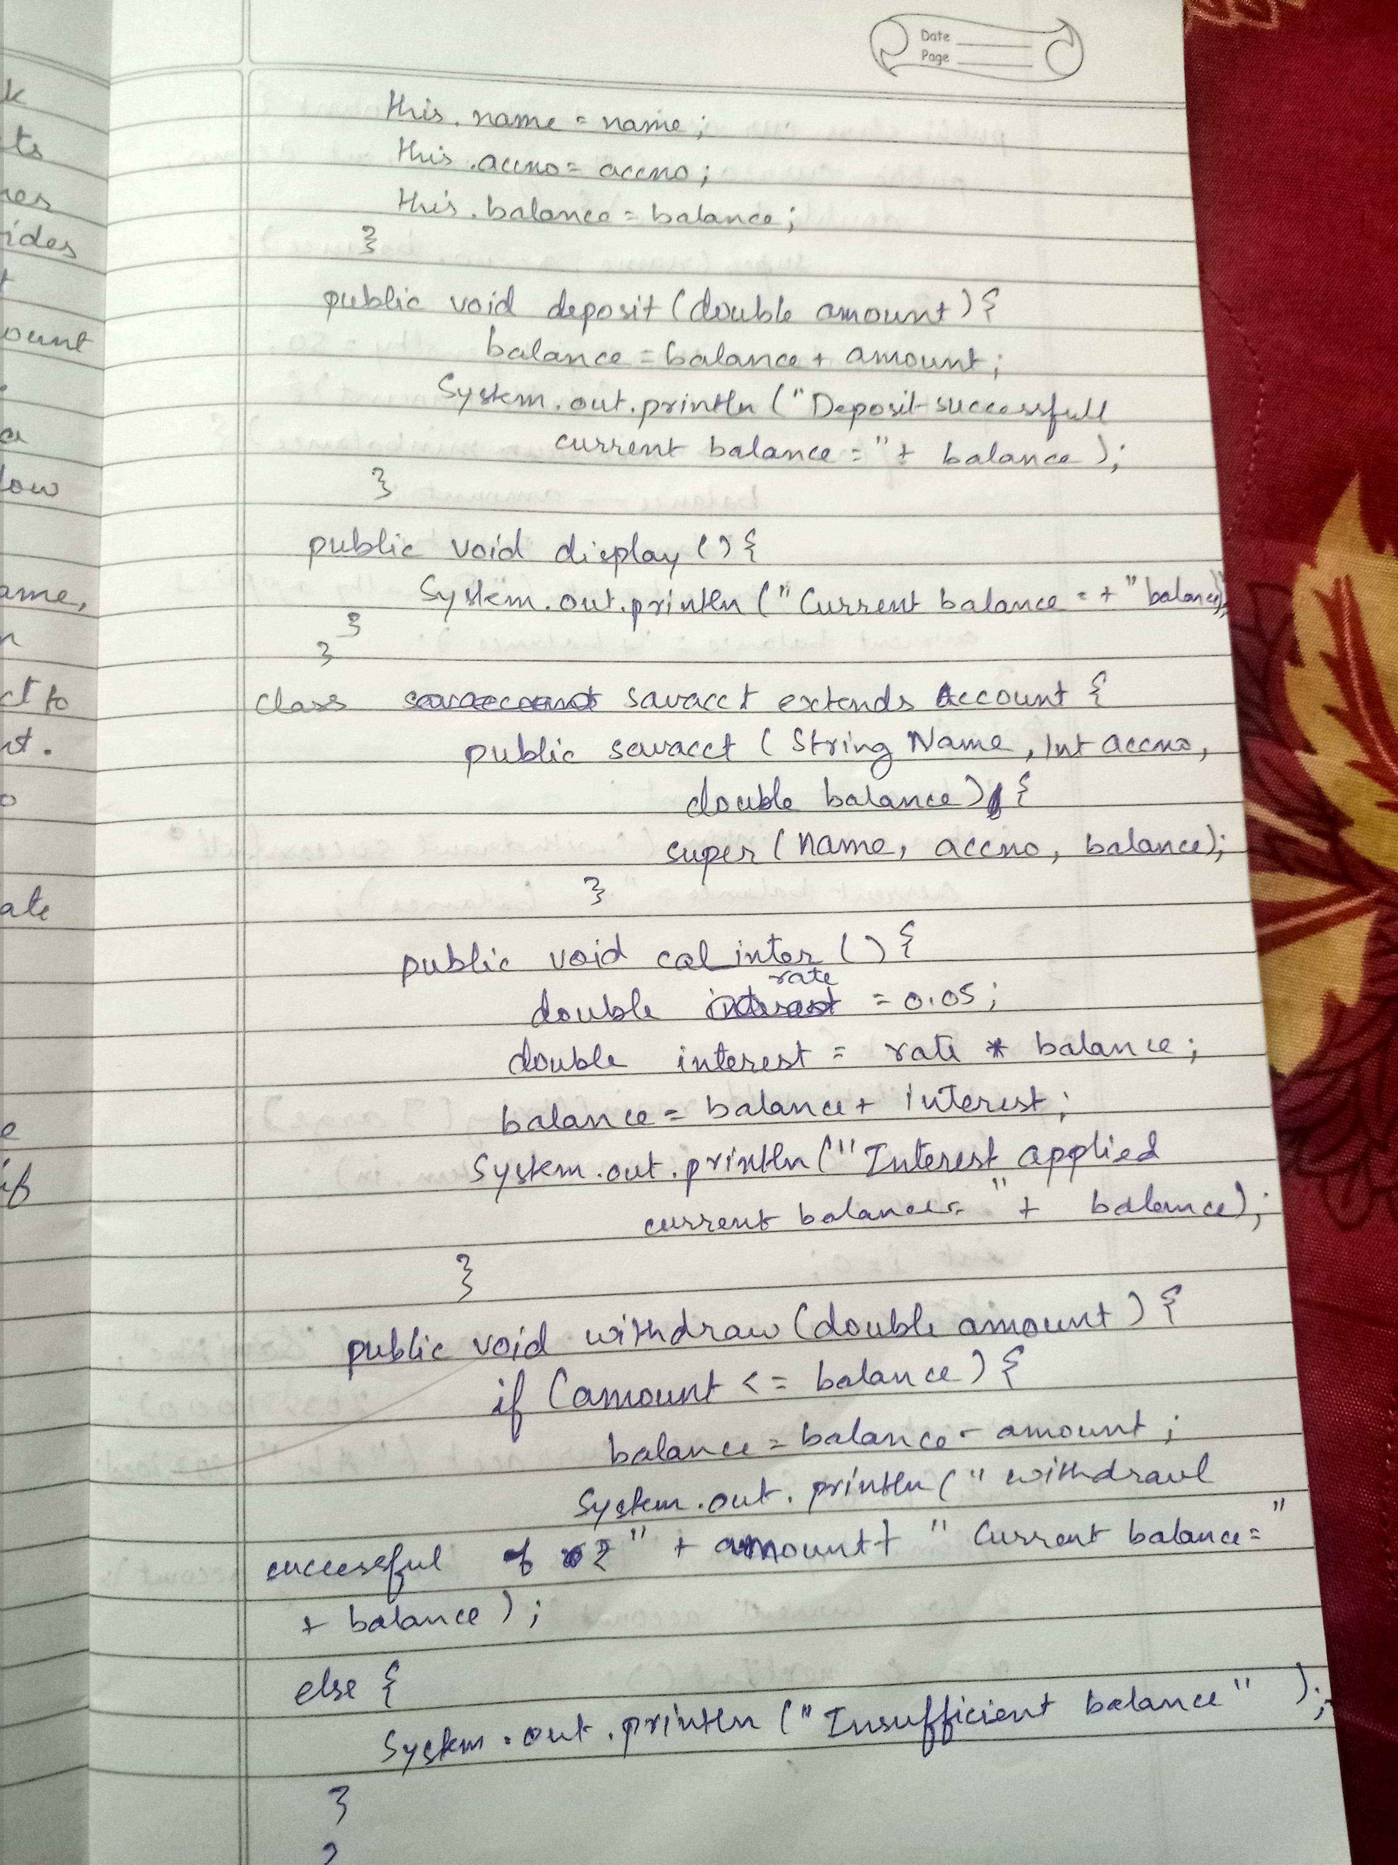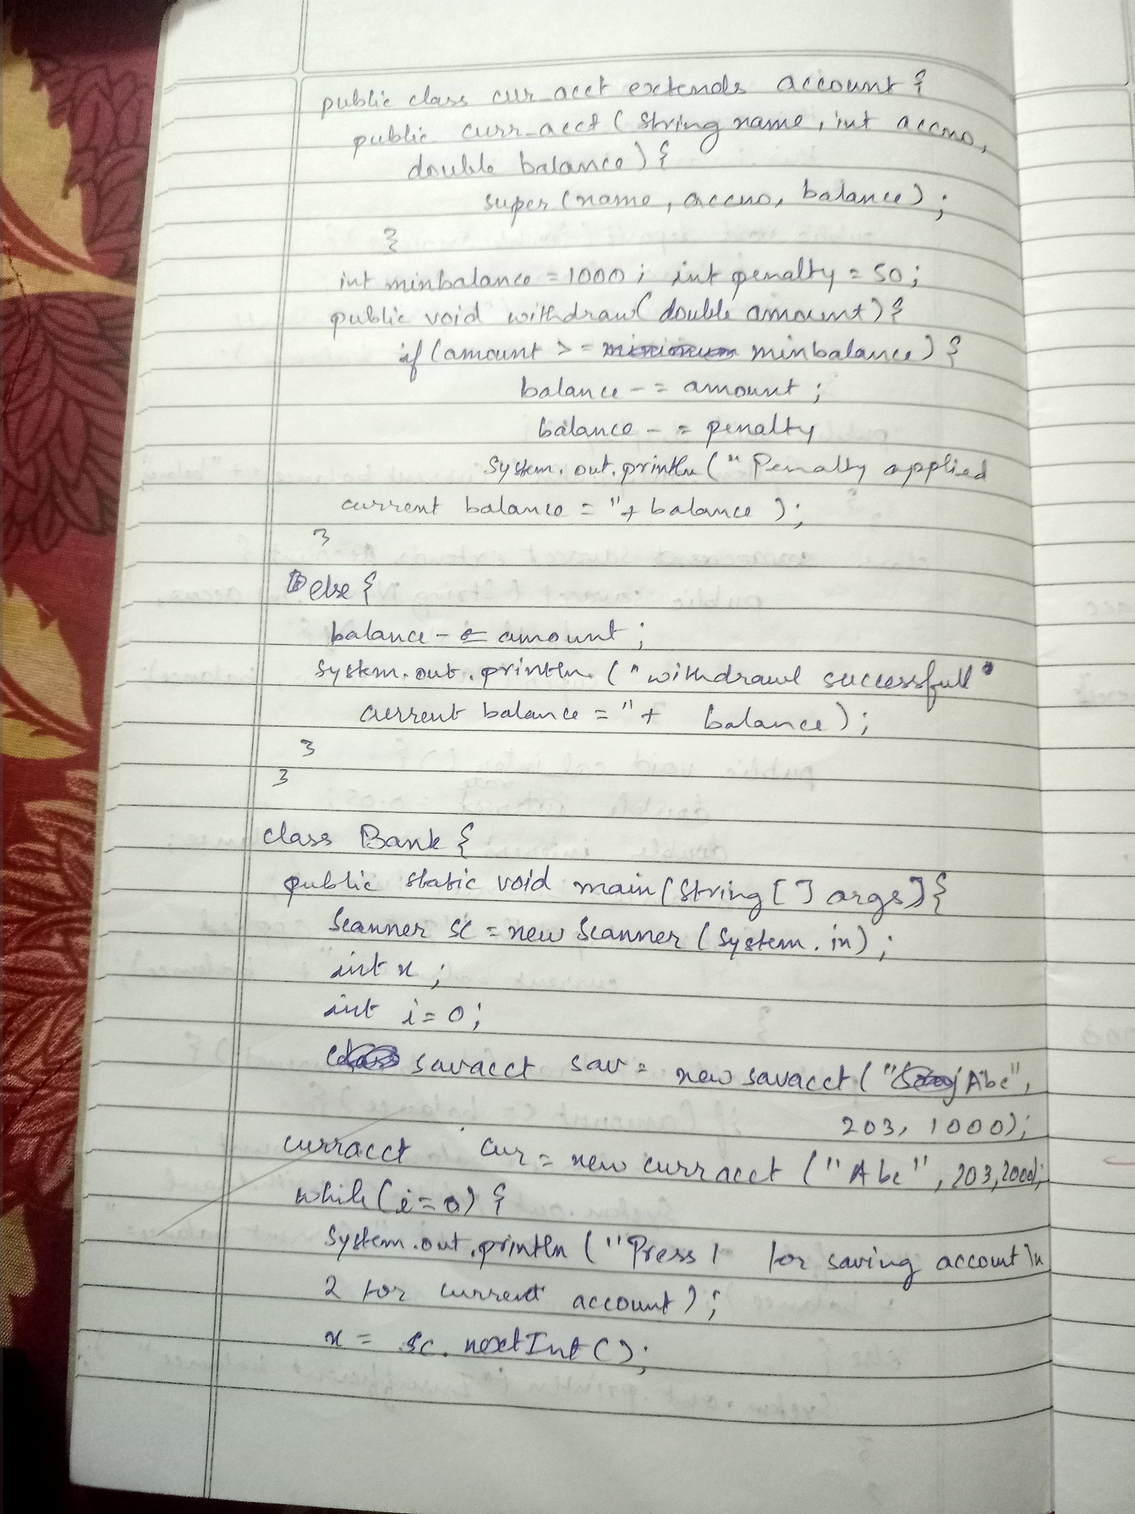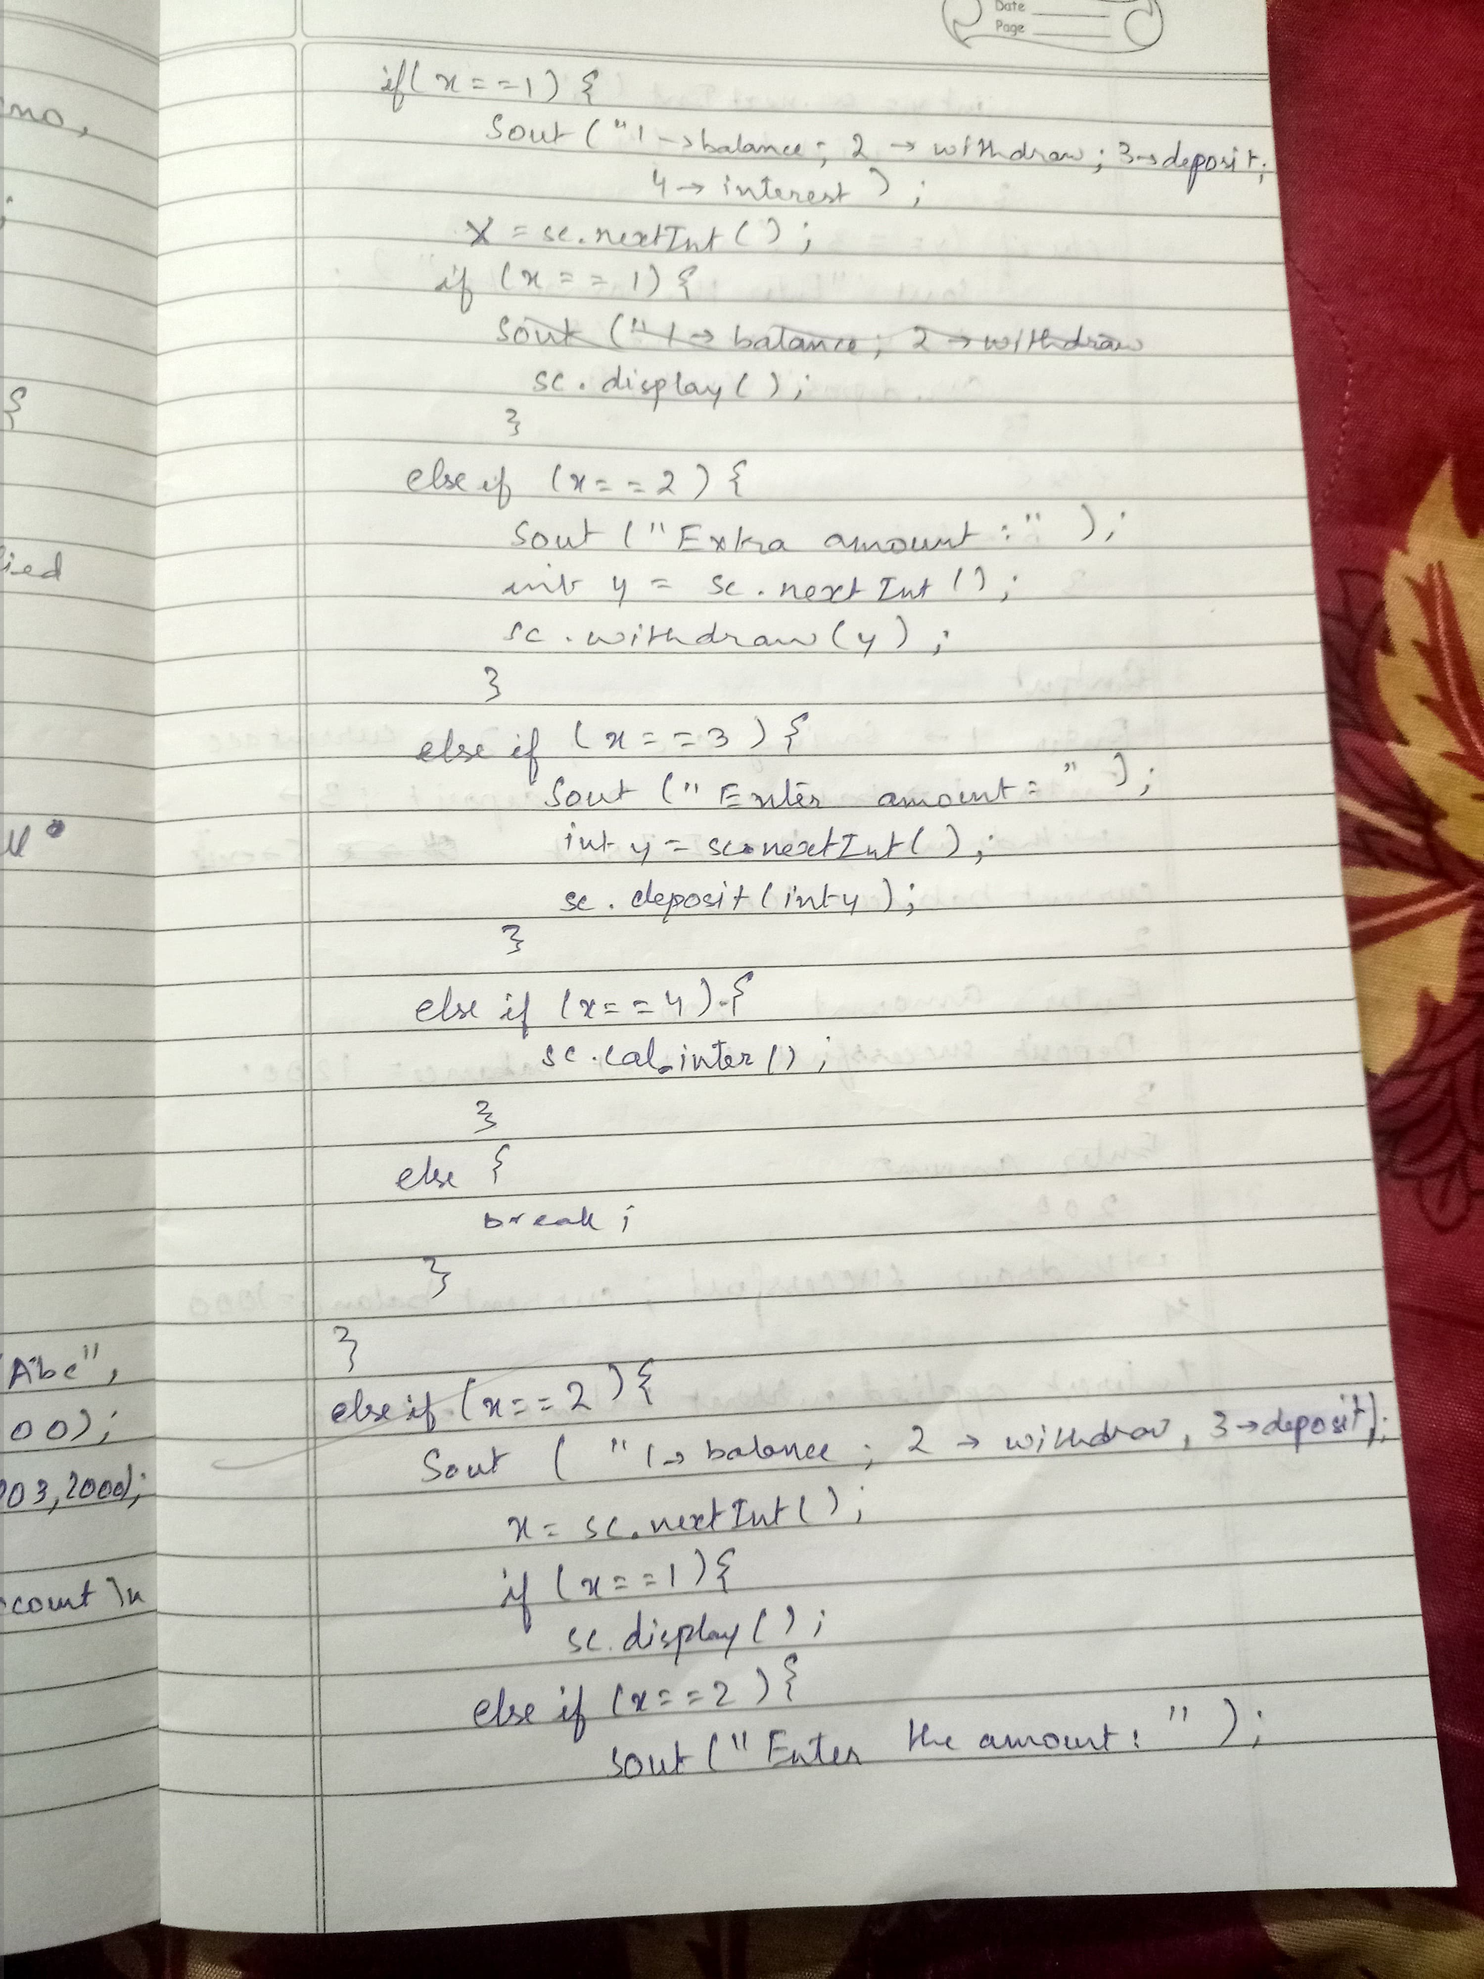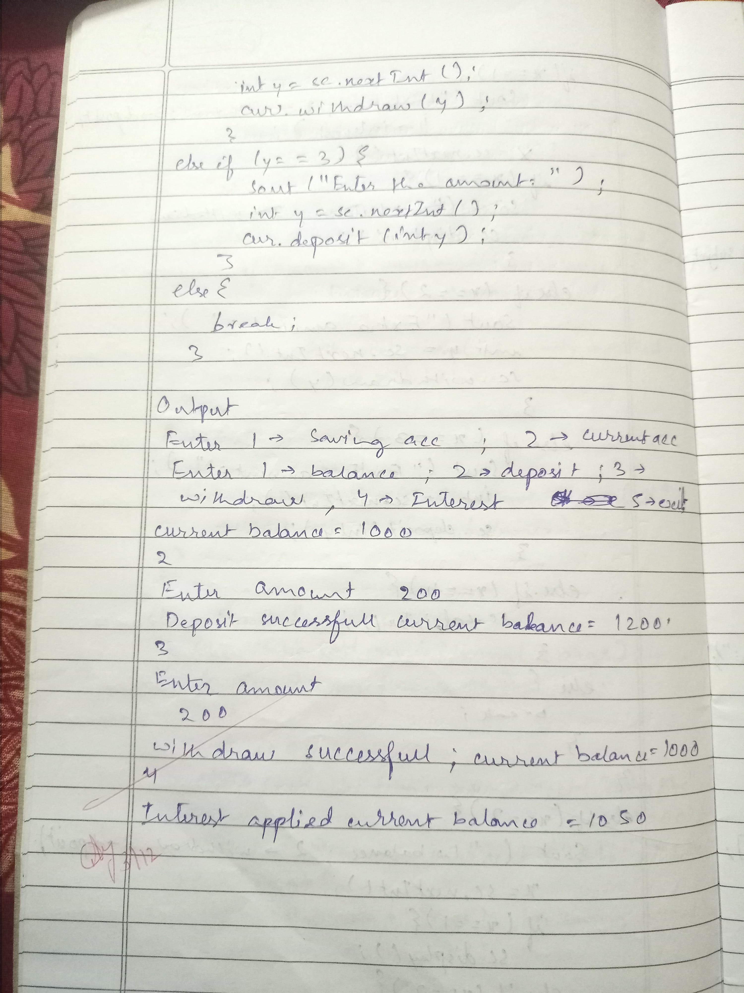

OUTPUT:

Press 1 for Savings Account, 2 for Current Account, 0 to Exit:

1

1 - Display Balance

2 - Withdraw

3 - Deposit

4 - Calculate Interest

1

Current balance = 1000.0

Press 1 for Savings Account, 2 for Current Account, 0 to Exit:

1

1 - Display Balance

2 - Withdraw

3 - Deposit

4 - Calculate Interest

3

Enter amount to deposit: 500

Deposit successful! Current balance = 1500.0

Press 1 for Savings Account, 2 for Current Account, 0 to Exit:

1

1 - Display Balance

2 - Withdraw

3 - Deposit

4 - Calculate Interest

2

Enter amount to withdraw: 200

Withdrawal successful! Current balance = 1300.0

Press 1 for Savings Account, 2 for Current Account, 0 to Exit:

1

1 - Display Balance

2 - Withdraw

3 - Deposit

4 - Calculate Interest

4

Interest applied! Current balance = 1365.0

Press 1 for Savings Account, 2 for Current Account, 0 to Exit:

2

1 - Display Balance

2 - Withdraw

3 - Deposit

1

Current balance = 2000.0

Press 1 for Savings Account, 2 for Current Account, 0 to Exit:

2

1 - Display Balance

2 - Withdraw

3 - Deposit

2

Enter amount to withdraw: 1950

Penalty applied! Current balance = 1950.0

Press 1 for Savings Account, 2 for Current Account, 0 to Exit:

PROGRAM 6:

package CIE;

public class Student {

public String USN;

public String Name;

public int Sem;

public Student(String USN, String Name, int Sem) {

this.USN = USN;

this.Name = Name;

this.Sem = Sem;

}

public void displayDetails() {

System.out.println("USN: " + USN);

System.out.println("Name: " + Name);

System.out.println("Semester: " + Sem);

}

}

package CIE;

import java.util.Scanner;

public class Internals extends Student {

public int[] marks = new int[5];

Scanner input = new Scanner(System.in);

public Internals(String USN, String Name, int Sem) {

super(USN, Name, Sem);

}

public void setMarks() {

System.out.println("Enter the internal marks for 5 subjects:");

for (int i = 0; i < 5; i++) {

marks[i] = input.nextInt();

}

}

public void displayMarks() {

System.out.print("Internal Marks: ");

for (int mark : marks) {

System.out.print(mark + " ");

}

System.out.println();

}

}

package SEE;

import CIE.Internals;

import java.util.Scanner;

public class External extends Internals {

protected int[] externalMarks = new int[5];

protected int[] finalMarks = new int[5];

Scanner input = new Scanner(System.in);

public External(String USN, String Name, int Sem) {

super(USN, Name, Sem);

}

public void setMarksSEE() {

System.out.println("Enter the external marks for 5 subjects:");

for (int i = 0; i < 5; i++) {

externalMarks[i] = input.nextInt();

}

}

public void calcFinalMarks() {

System.out.println("Final Marks:");

for (int i = 0; i < 5; i++) {

finalMarks[i] = marks[i] + externalMarks[i];

System.out.println("Subject " + (i + 1) + ": " + finalMarks[i]);

}

}

}

import SEE.External;

import java.util.Scanner;

public class Main {

public static void main(String[] args) {

int n = 3;

External[] students = new External[n];

Scanner scanner = new Scanner(System.in);

for (int i = 0; i < n; i++) {

System.out.println("Enter details for student " + (i + 1) + ":");

System.out.print("Name: ");

String name = scanner.nextLine();

System.out.print("USN: ");

String usn = scanner.nextLine();

System.out.print("Semester: ");

int sem = scanner.nextInt();

students[i] = new External(usn, name, sem);

students[i].setMarks();

students[i].setMarksSEE();

scanner.nextLine(); // Clear the newline

}

System.out.println("\nStudent Details and Final Marks:");

for (External student : students) {

student.displayDetails();

student.displayMarks();

student.calcFinalMarks();

}

scanner.close();

}

}

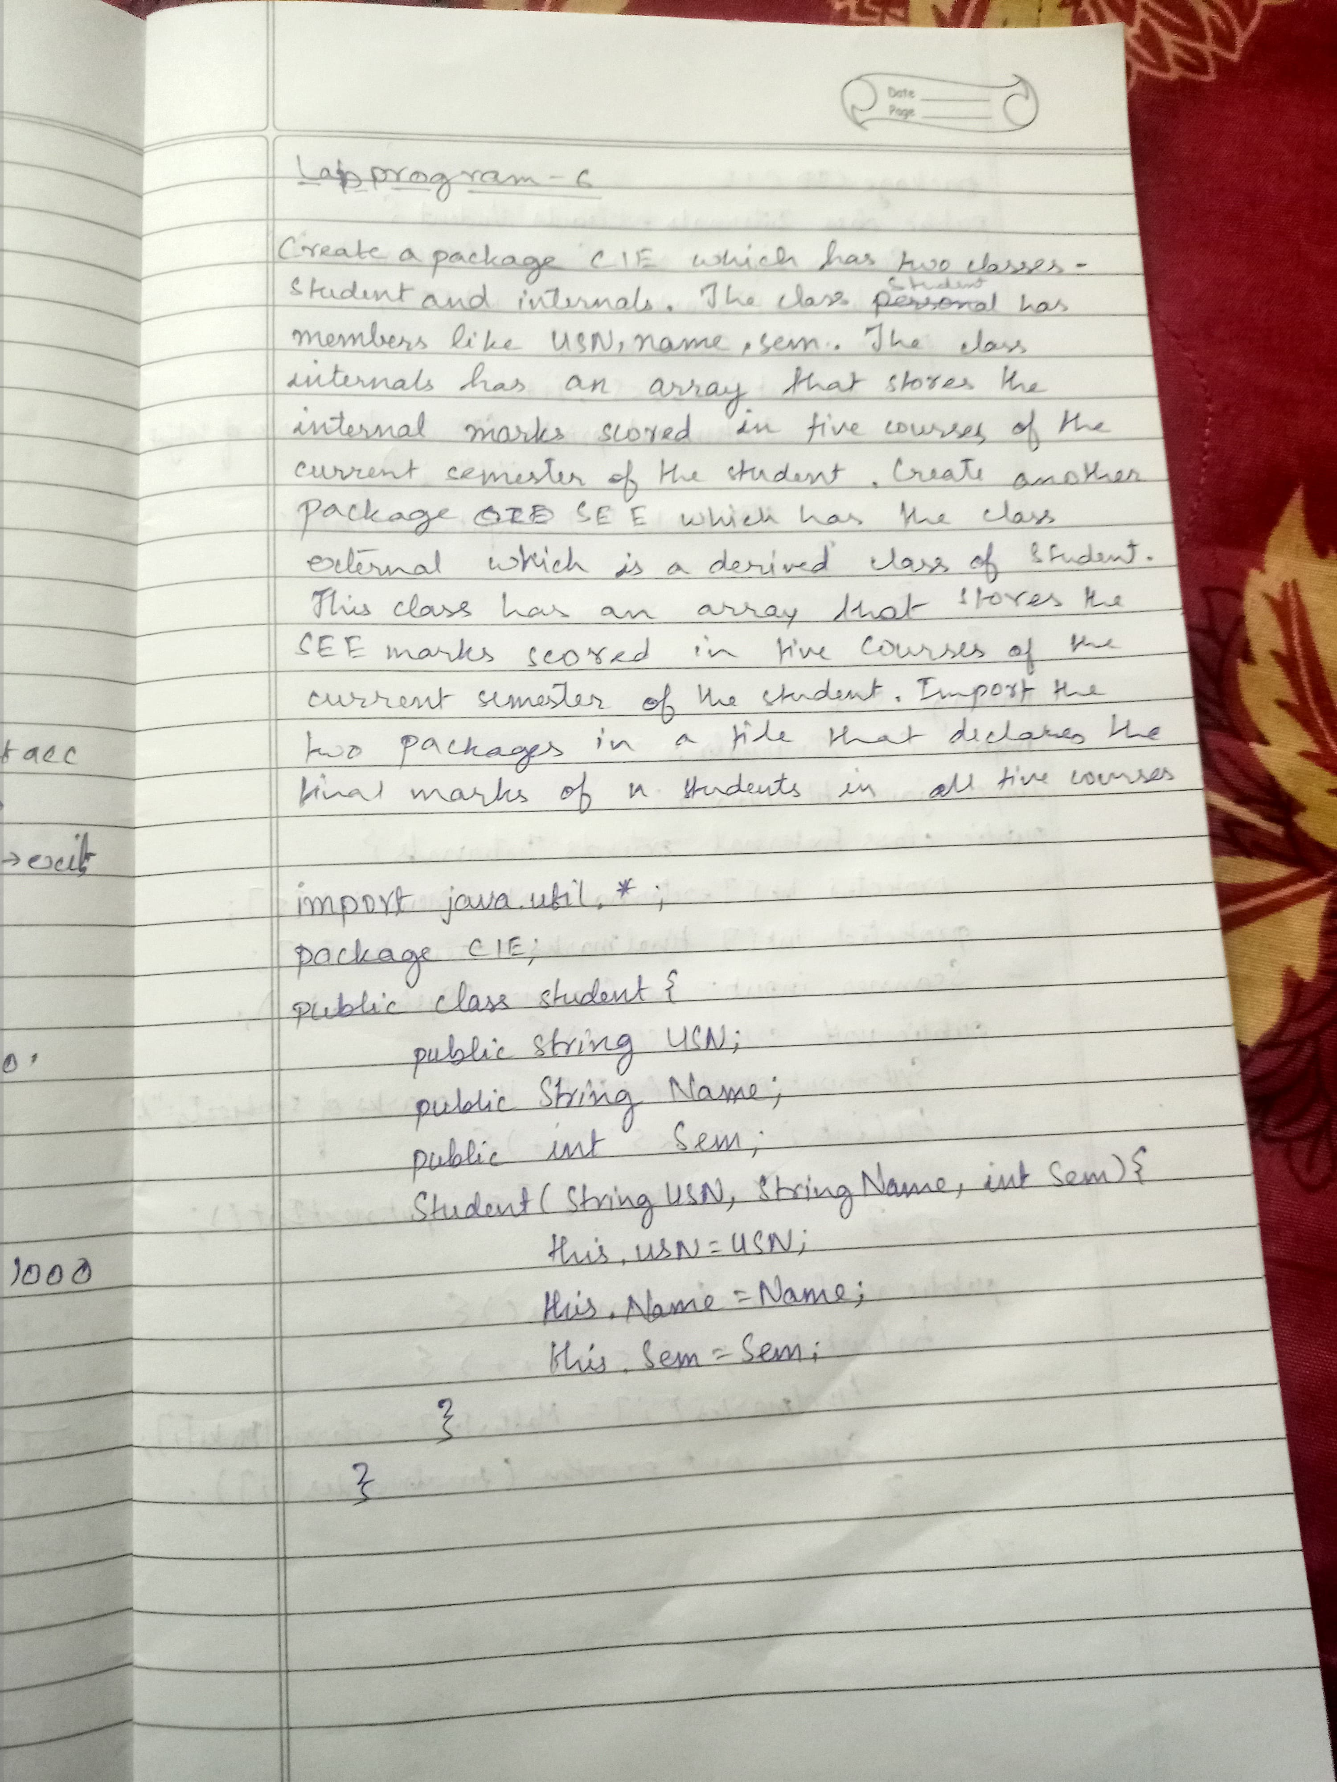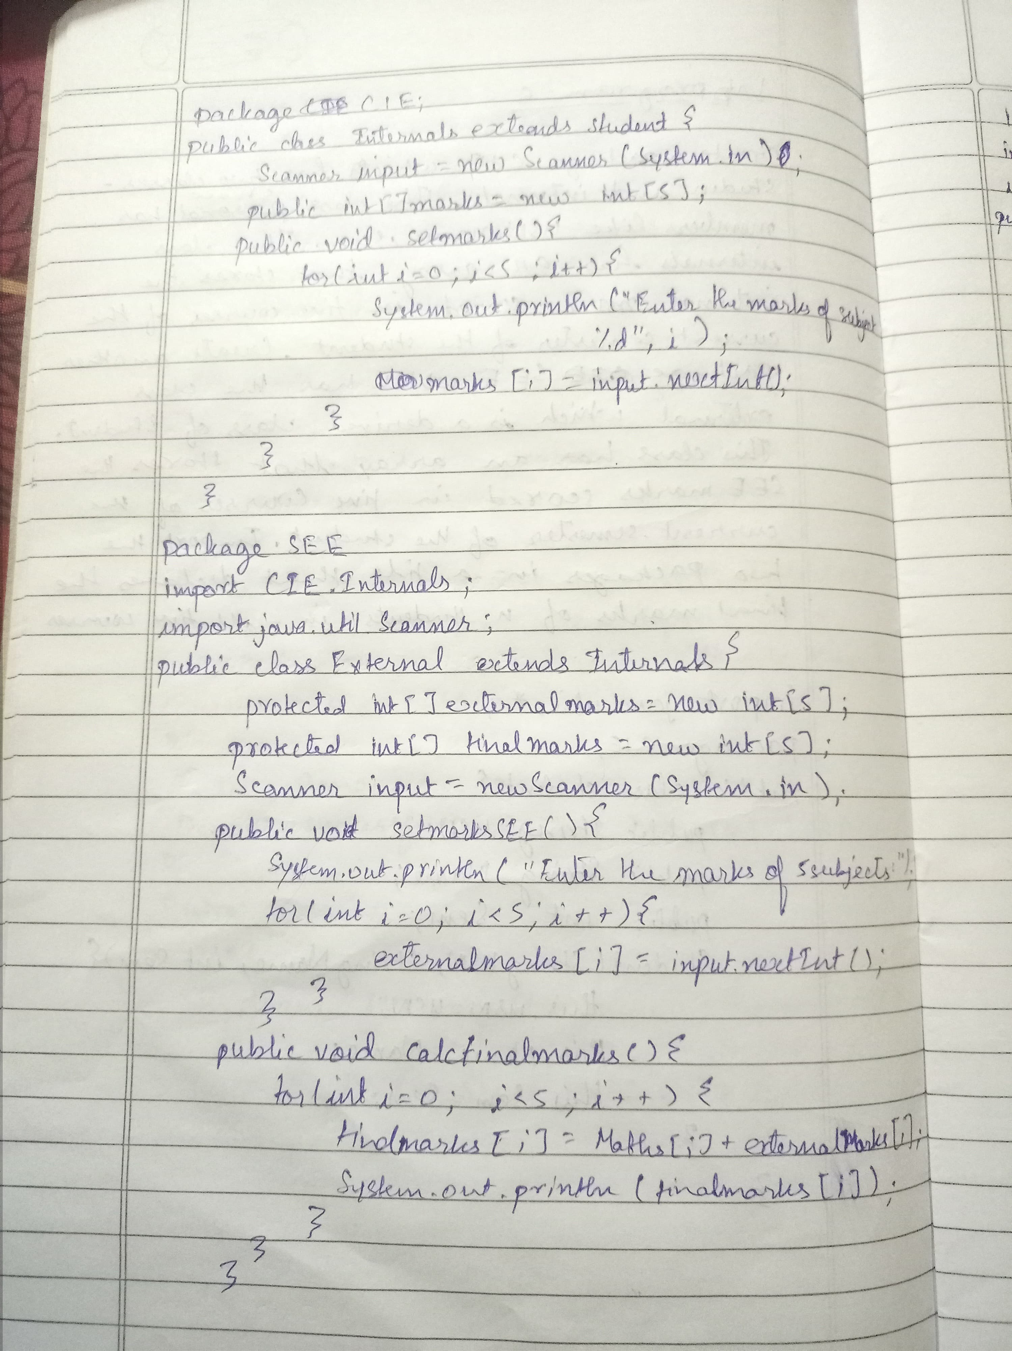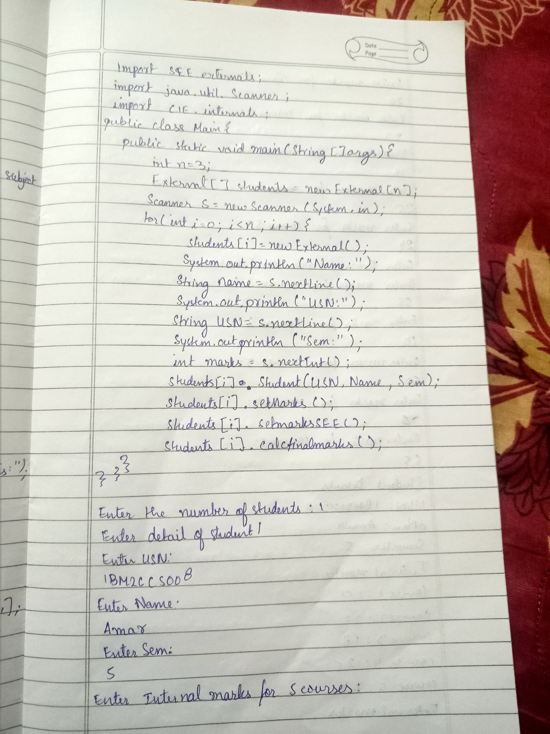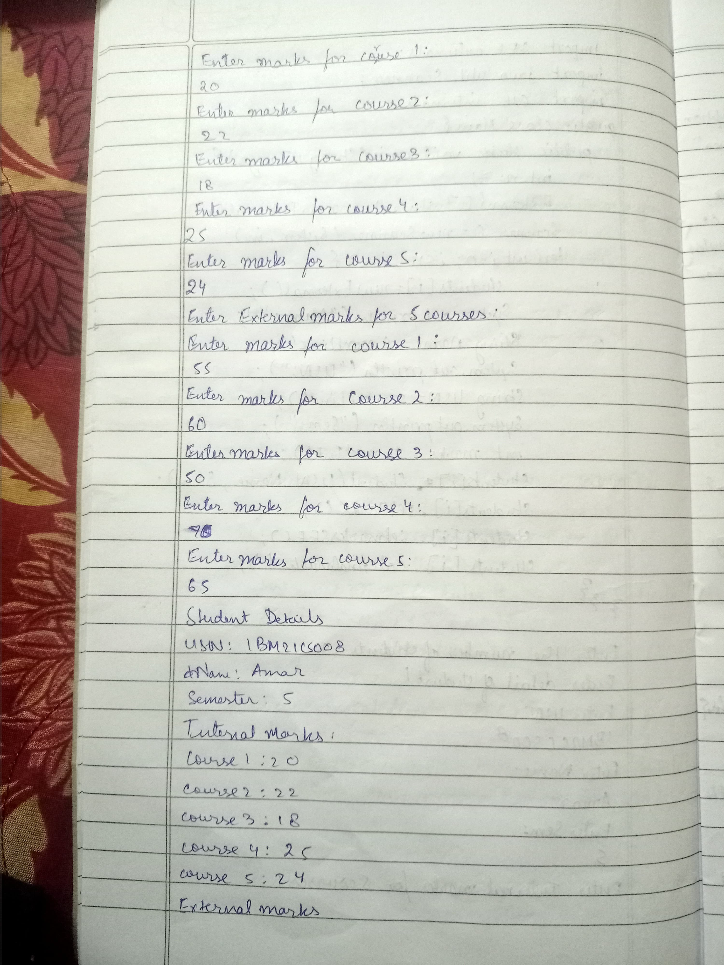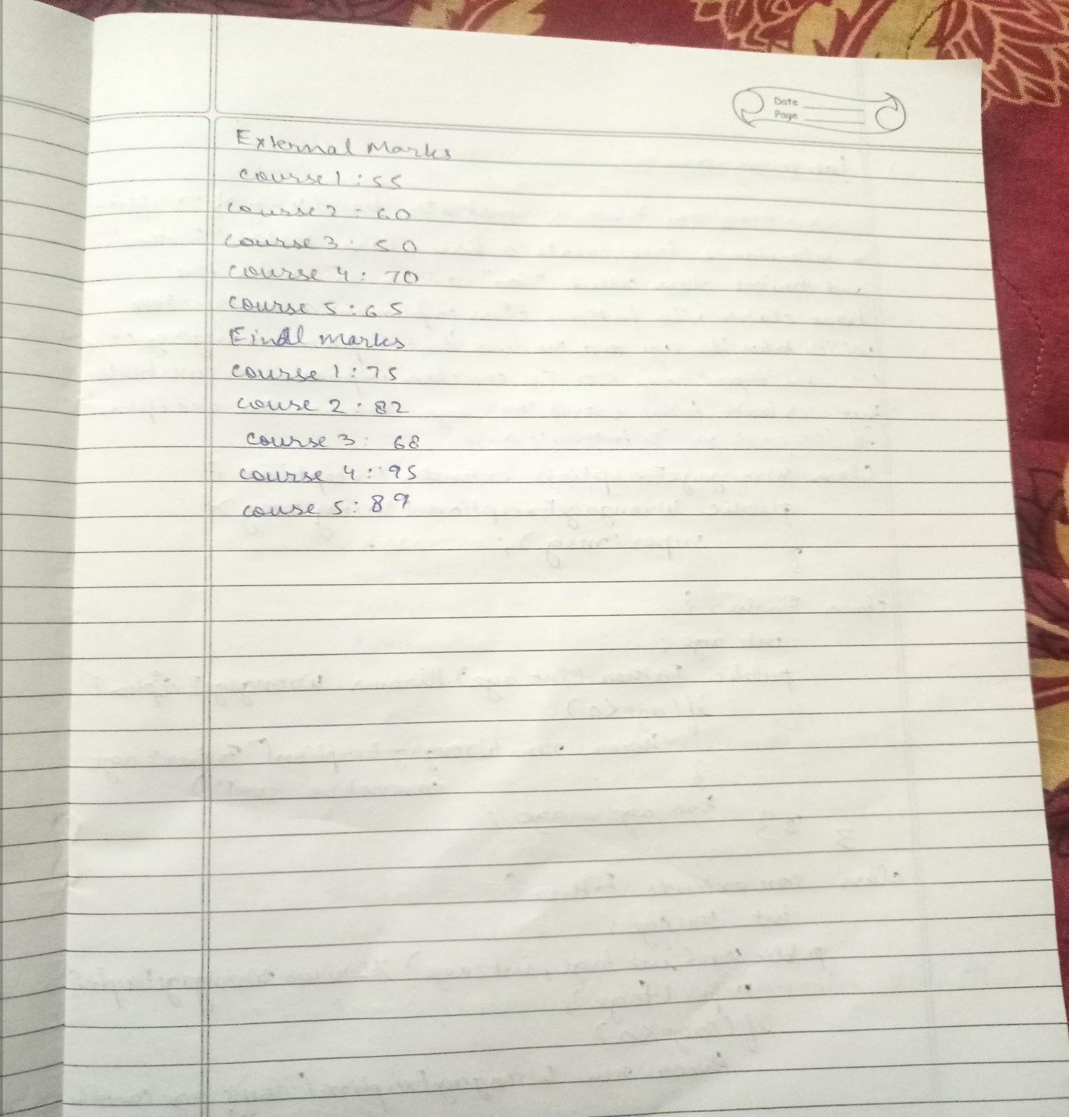

OUTPUT:

Enter details for student 1:

Name: John

USN: 1CE21CS001

Semester: 5

Enter the internal marks for 5 subjects:

20 18 17 19 20

Enter the external marks for 5 subjects:

60 65 70 75 80

Enter details for student 2:

Name: Mary

USN: 1CE21CS002

Semester: 5

Enter the internal marks for 5 subjects:

19 18 20 18 19

Enter the external marks for 5 subjects:

55 60 65 70 75

Enter details for student 3:

Name: Alex

USN: 1CE21CS003

Semester: 5

Enter the internal marks for 5 subjects:

20 19 18 20 20

Enter the external marks for 5 subjects:

70 75 80 85 90

Student Details and Final Marks:

USN: 1CE21CS001

Name: John

Semester: 5

Internal Marks: 20 18 17 19 20

Final Marks:

Subject 1: 80

Subject 2: 83

Subject 3: 87

Subject 4: 94

Subject 5: 100

USN: 1CE21CS002

Name: Mary

Semester: 5

Internal Marks: 19 18 20 18 19

Final Marks:

Subject 1: 74

Subject 2: 78

Subject 3: 85

Subject 4: 88

Subject 5: 94

USN: 1CE21CS003

Name: Alex

Semester: 5

Internal Marks: 20 19 18 20 20

Final Marks:

Subject 1: 90

Subject 2: 94

Subject 3: 98

Subject 4: 105

Subject 5: 110

PROGRAM 7

import java.util.Scanner;

class wrongage extends Exception{

public wrongage(String msg){

super(msg);

}

}

class father{

int age;

public father(int age)throws wrongage{

if(age<0){

throw new wrongage("age can not be negative");

}

this.age=age;

}

}

class son extends father{

int sage;

public son(int fage,int sage) throws wrongage{

super(fage);

if(sage<0){

throw new wrongage("son age can not be negative");

}

if(sage>=fage){

throw new wrongage("son age can not be greater than father age");

}

this.sage=sage;

}

}

public class lab7{

public static void main(String[] args){

Scanner sc=new Scanner(System.in);

System.out.print("enter father age=");

int fage=sc.nextInt();

System.out.print("enter son age=");

int sage=sc.nextInt();

try{

son son=new son(fage,sage);

System.out.print("the difference is");

System.out.print(fage-sage);

}

catch (Exception e){

System.out.println(e.getMessage());

}

}

}

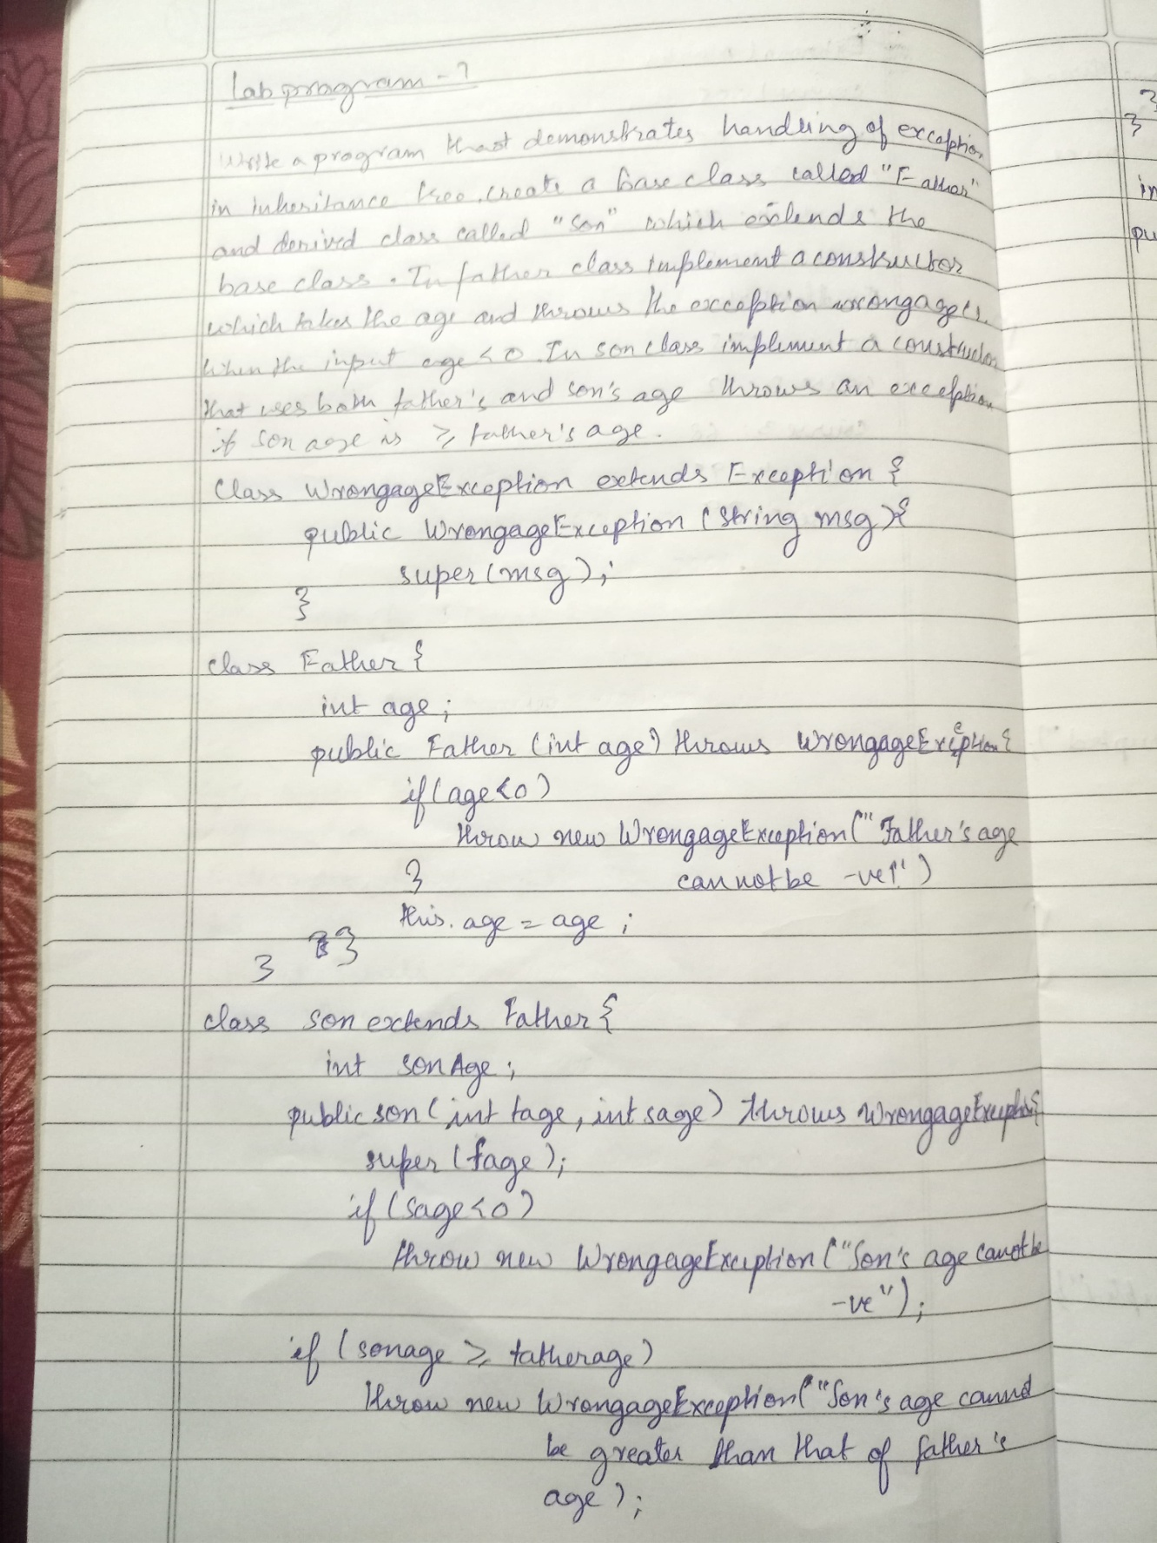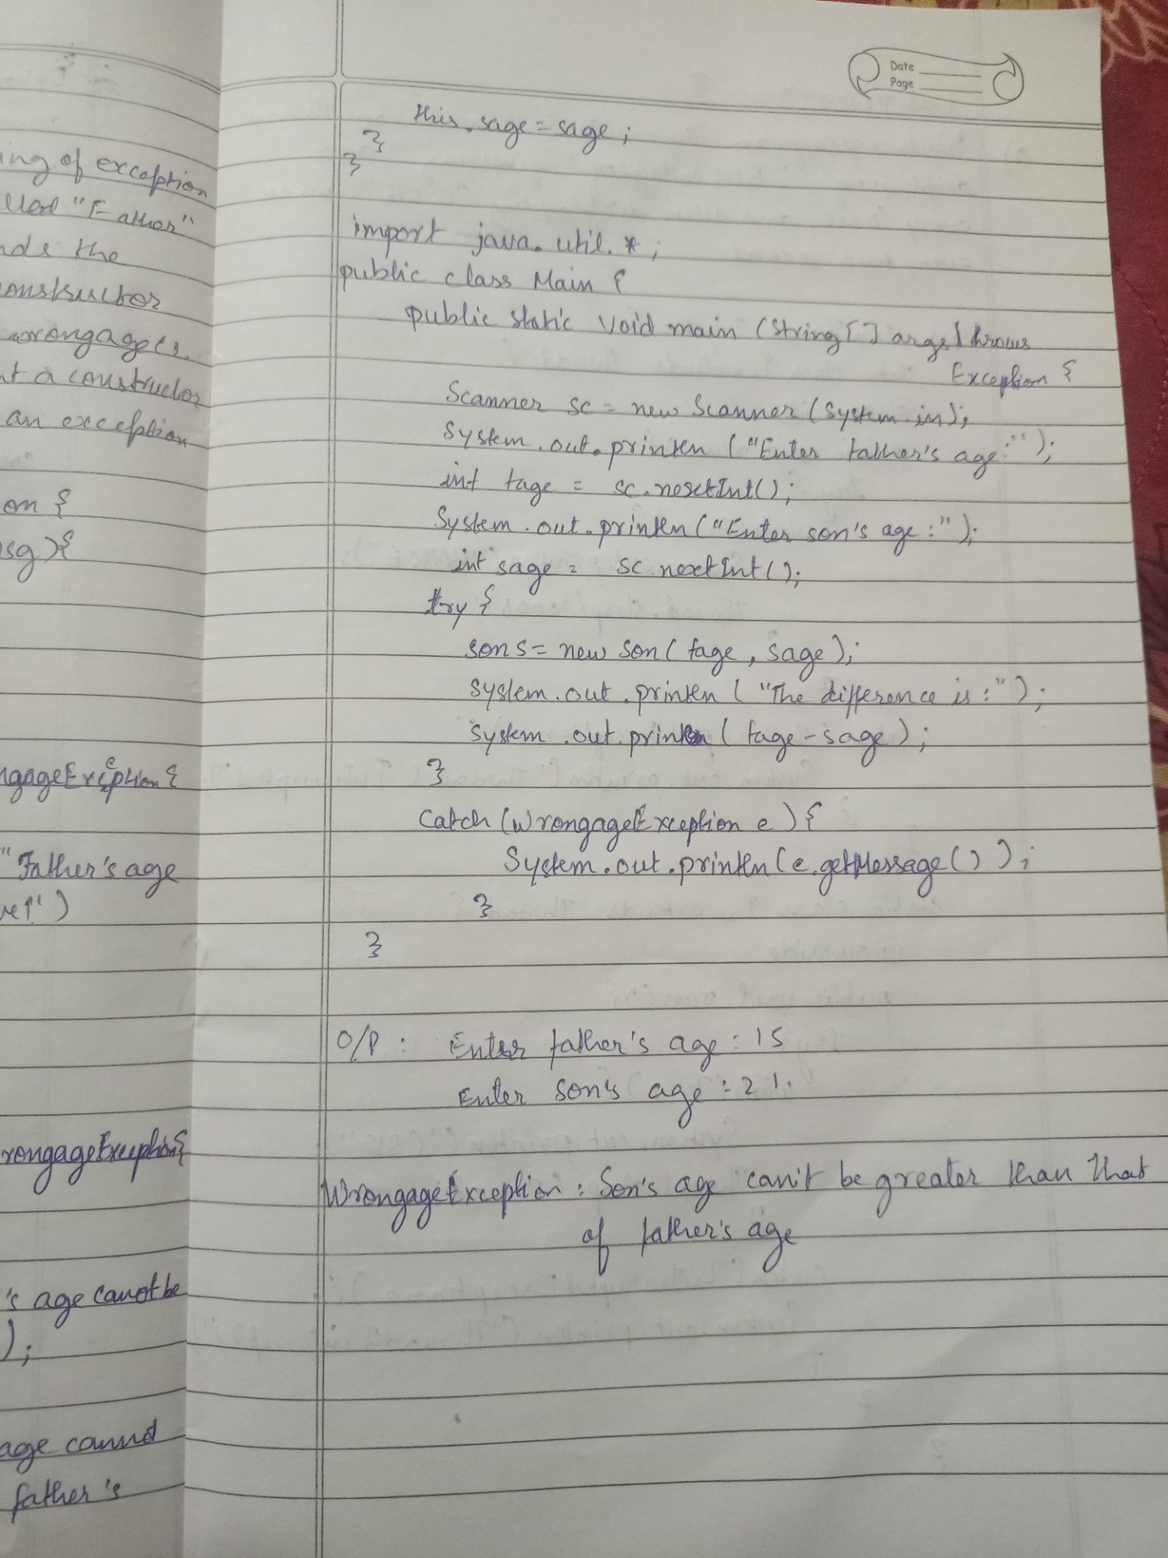

OUTPUT:

enter father age=40

enter son age=20

the difference is 20

PROGRAM 8:

class mythread1 extends Thread{

public void run(){

try{

while(true){

System.out.println("Bmsce");

Thread.sleep(10000);

}

}

catch(Exception e){

System.out.println("Thread 1 in interrupted");

}

}

}

class mythread2 extends Thread{

public void run(){

try{

while(true){

System.out.println("CSE");

Thread.sleep(2000);

}

}

catch(Exception e){

System.out.println("Thread 2 in interrupted");

}

}

}

public class lab8{

public static void main(String[] args){

mythread1 t1=new mythread1();

mythread2 t2=new mythread2();

t1.start();

t2.start();

}

}

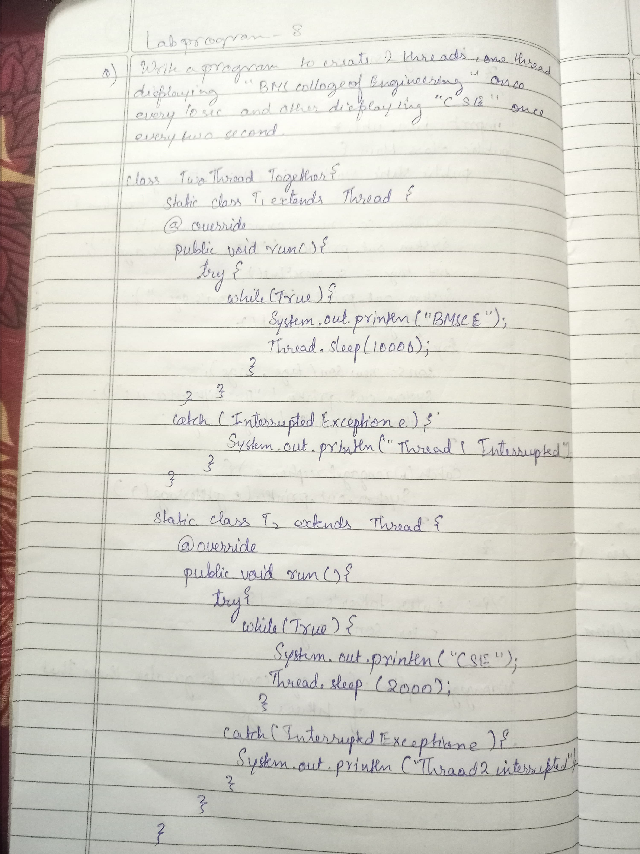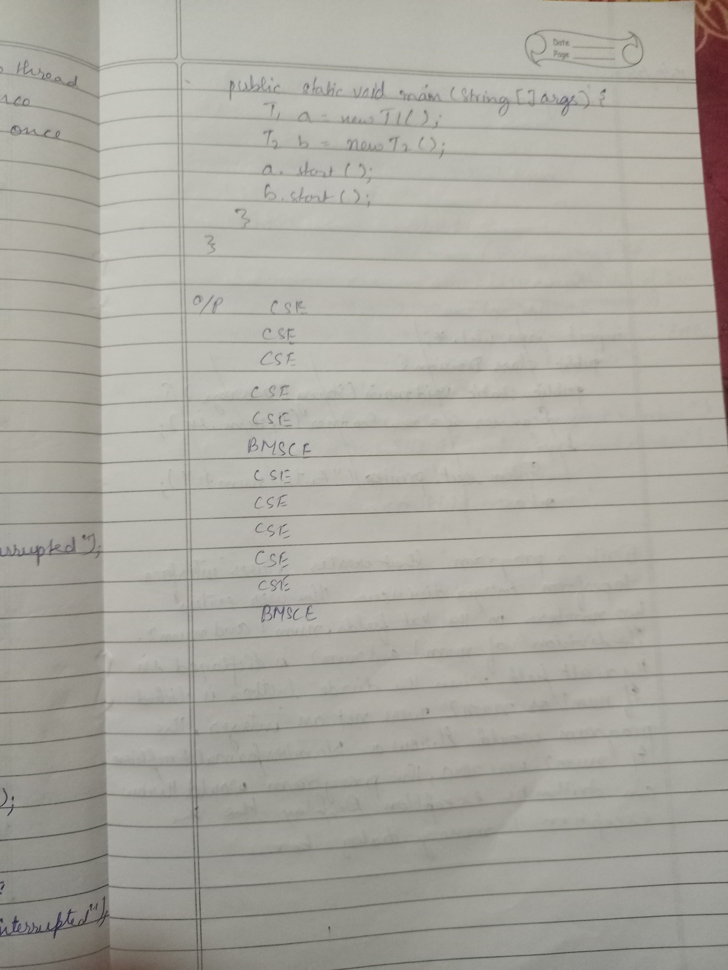

OUTPUT:

CSE

CSE

CSE

CSE

CSE

Bmsce

CSE

CSE

CSE

CSE

CSE

Bmsce

PROGRAM 9:

import javax.swing.*;

import java.awt.event.*;

class Division implements ActionListener {

static JLabel label1, label2, resultLabel;

static JTextField textField1, textField2;

public static void main(String[] args) {

JFrame frame = new JFrame("Division of Numbers");

frame.setDefaultCloseOperation(JFrame.EXIT_ON_CLOSE);

frame.setSize(400, 200);

label1 = new JLabel("Enter the first number: ");

label2 = new JLabel("Enter the second number: ");

resultLabel = new JLabel("Result will appear here.");

textField1 = new JTextField(10);

textField2 = new JTextField(10);

JButton submit = new JButton("Submit");

Division division = new Division();

submit.addActionListener(division);

JPanel panel = new JPanel();

panel.add(label1);

panel.add(textField1);

panel.add(label2);

panel.add(textField2);

panel.add(submit);

panel.add(resultLabel);

frame.add(panel);

frame.setVisible(true);

}

public void actionPerformed(ActionEvent e) {

try {

int num1 = Integer.parseInt(textField1.getText());

int num2 = Integer.parseInt(textField2.getText());

if (num2 == 0) {

resultLabel.setText("Error: Division by zero!");

} else {

int result = num1 / num2;

resultLabel.setText("The result of the division is: " + result);

}

} catch (NumberFormatException ex) {

resultLabel.setText("Error: Please enter valid numbers.");

}

}

}

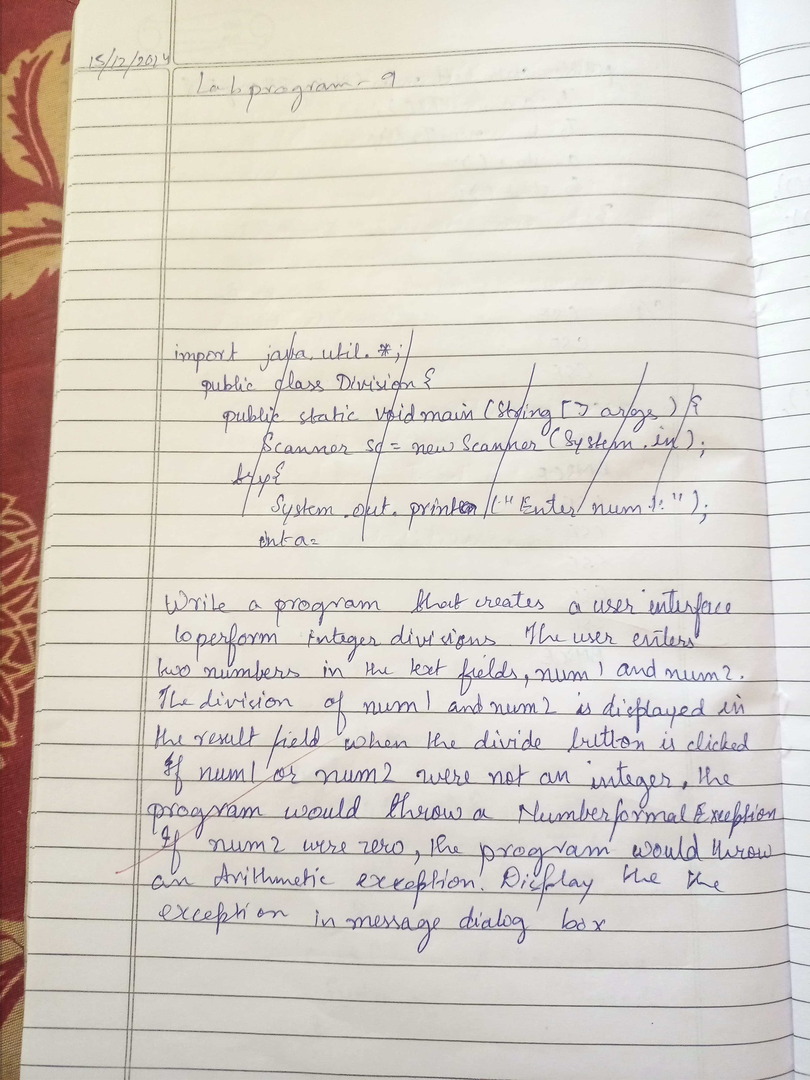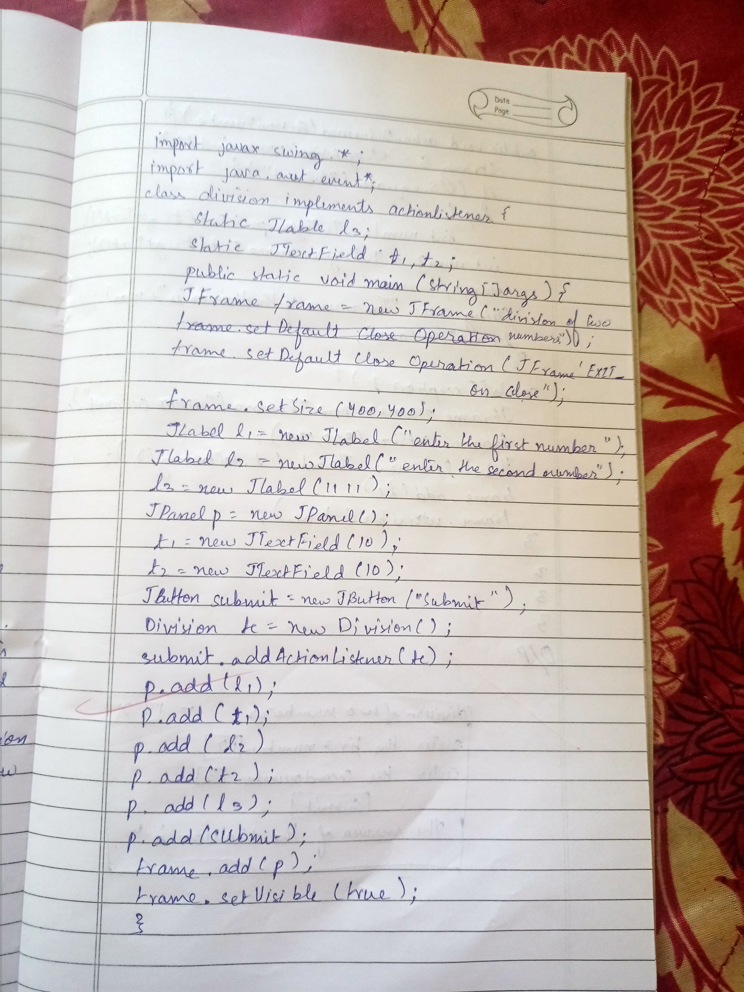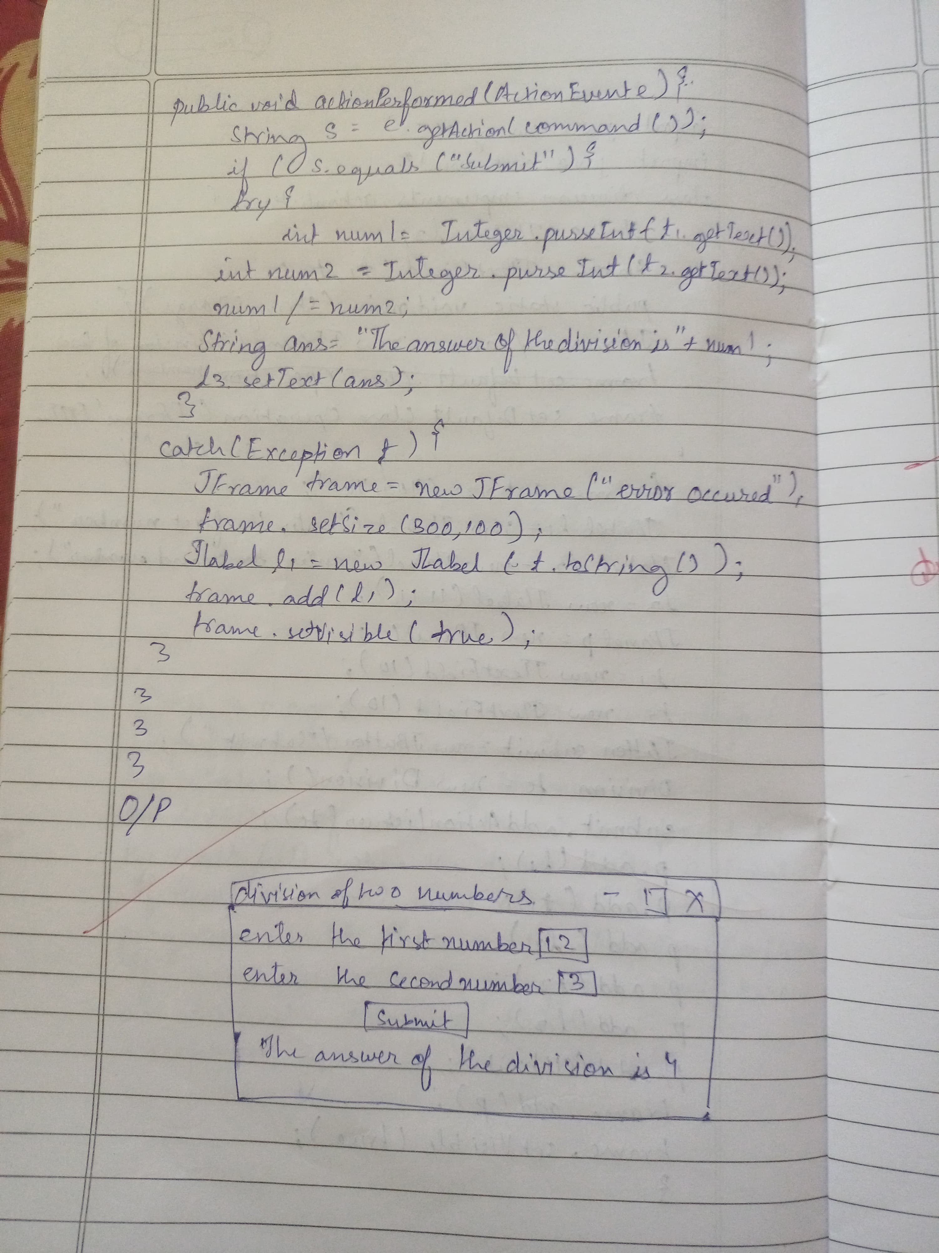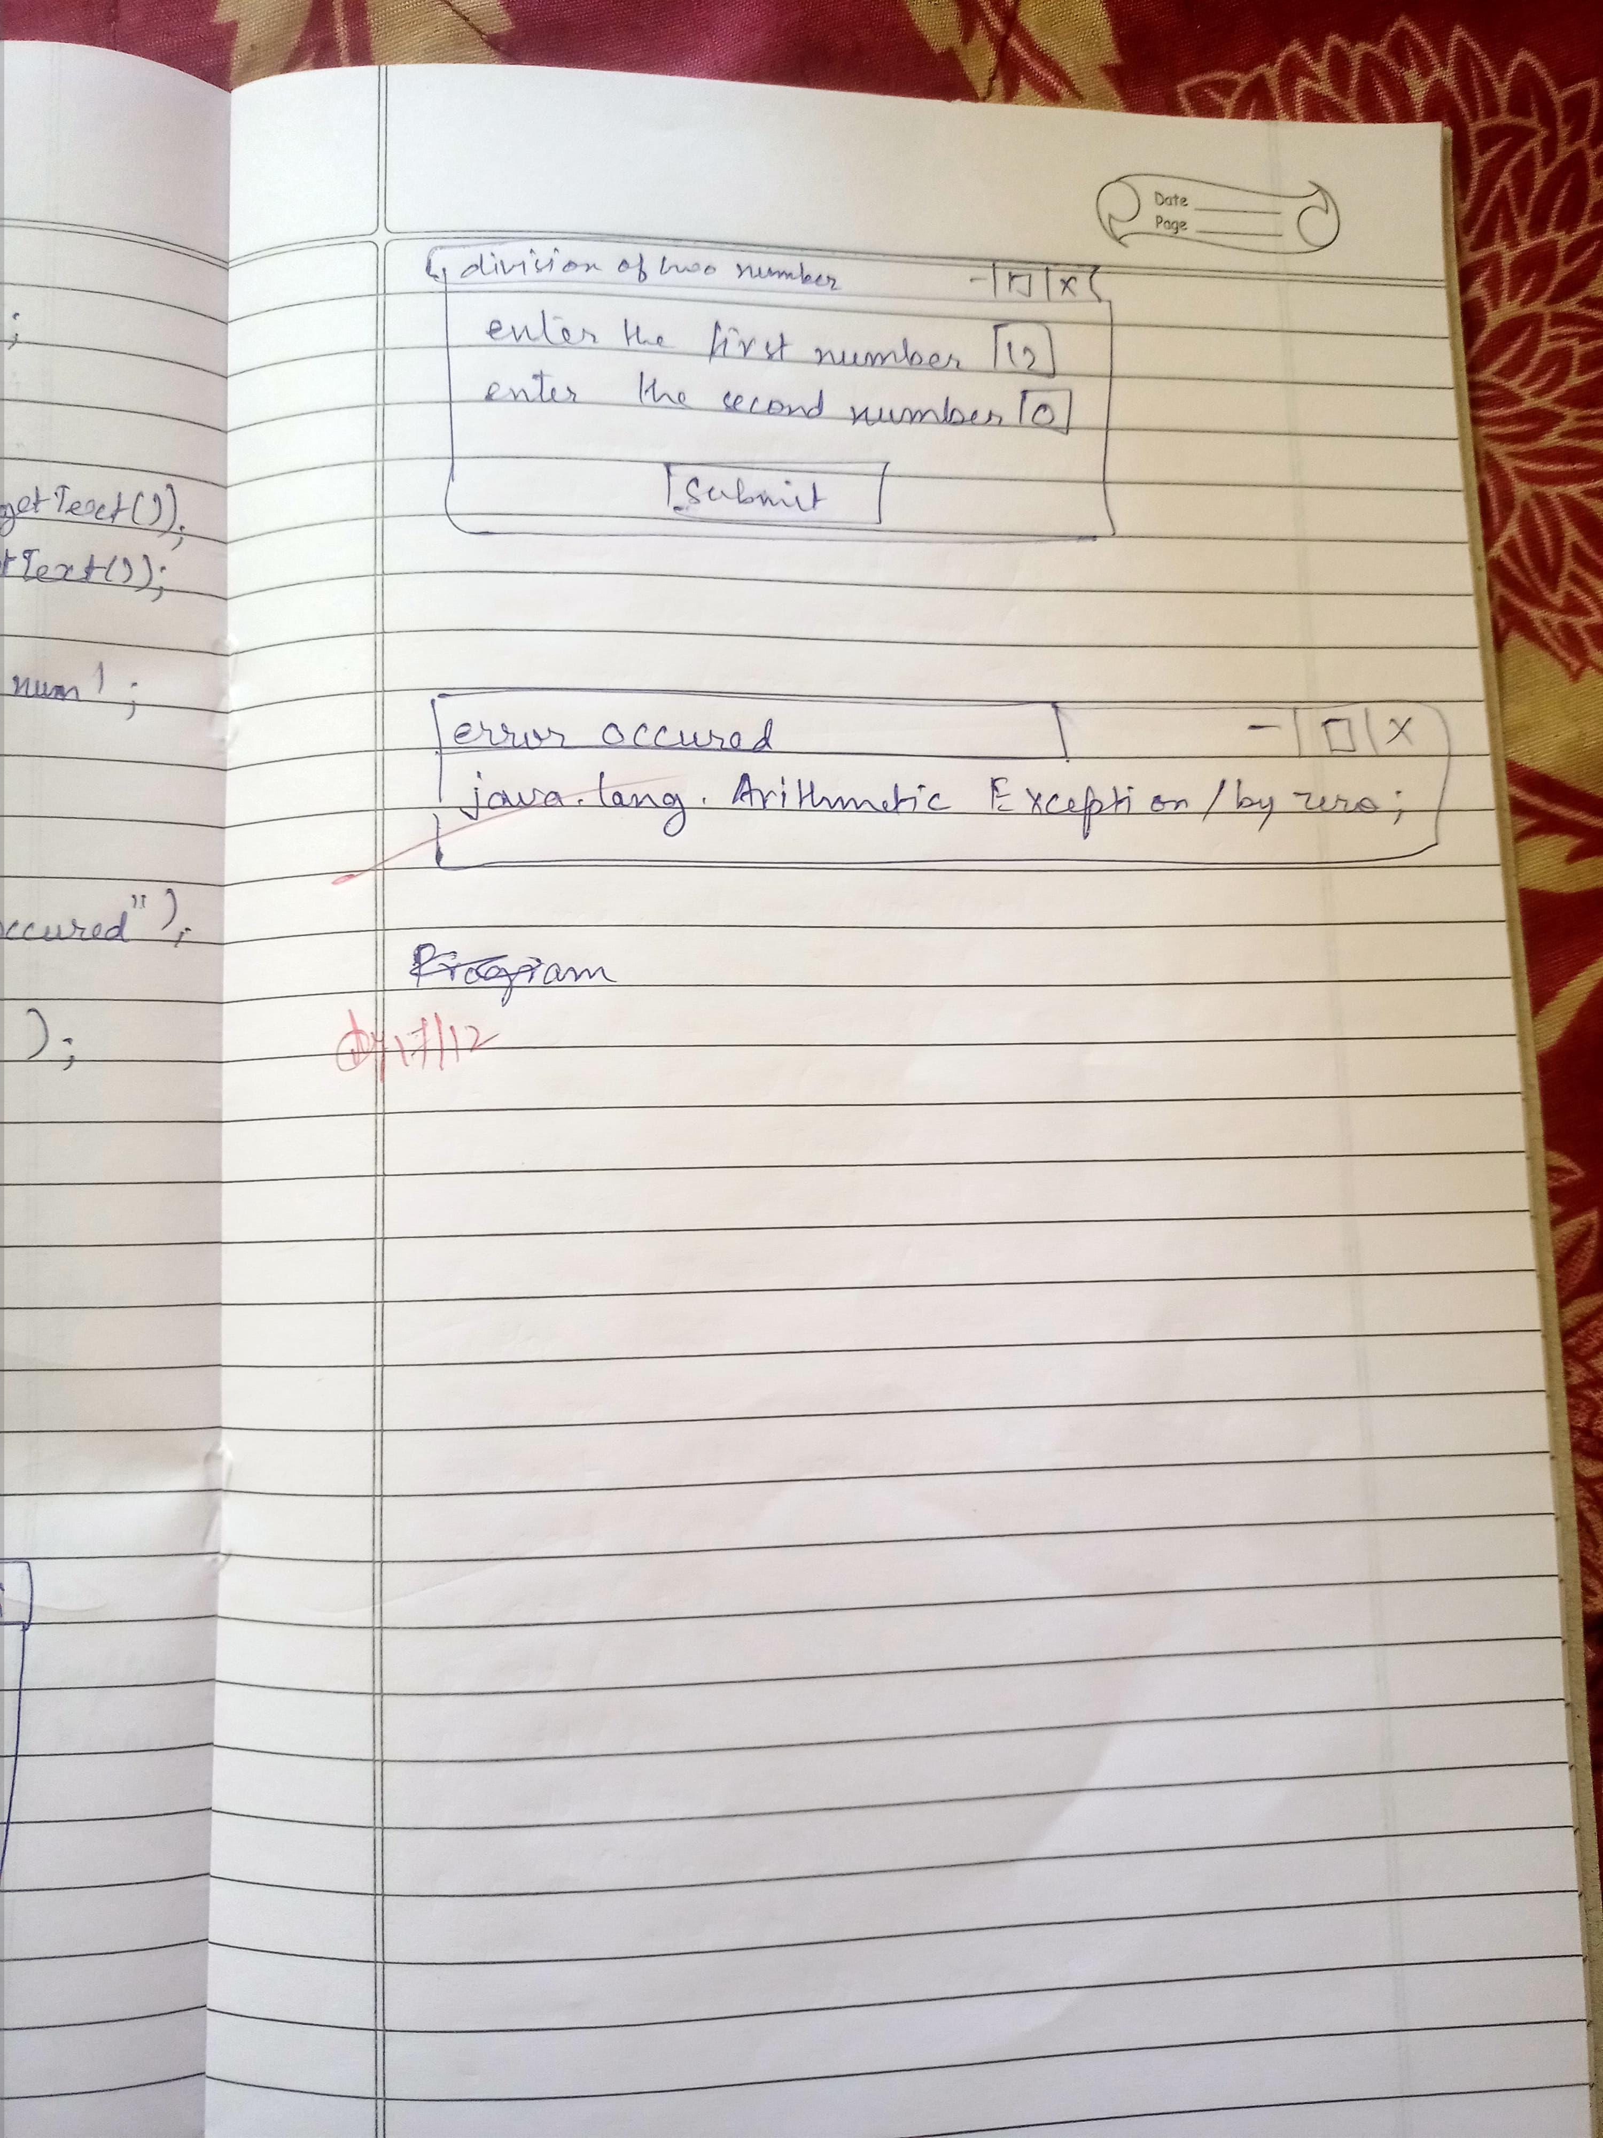

PROGRAM 10:

class SharedResource {

synchronized void method1(SharedResource other) {

System.out.println(Thread.currentThread().getName() + " is executing method1");

try { Thread.sleep(100); } catch (InterruptedException e) {}

System.out.println(Thread.currentThread().getName() + " is trying to call method2 on other resource");

other.method2(this);

}

synchronized void method2(SharedResource other) {

System.out.println(Thread.currentThread().getName() + " is executing method2");

try { Thread.sleep(100); } catch (InterruptedException e) {}

System.out.println(Thread.currentThread().getName() + " is trying to call method1 on other resource");

other.method1(this);

}

}

class DeadlockDemo {

public static void main(String[] args) {

SharedResource res1 = new SharedResource();

SharedResource res2 = new SharedResource();

Thread t1 = new Thread(() -> res1.method1(res2), "Thread-1");

Thread t2 = new Thread(() -> res2.method1(res1), "Thread-2");

t1.start();

t2.start();

}

}

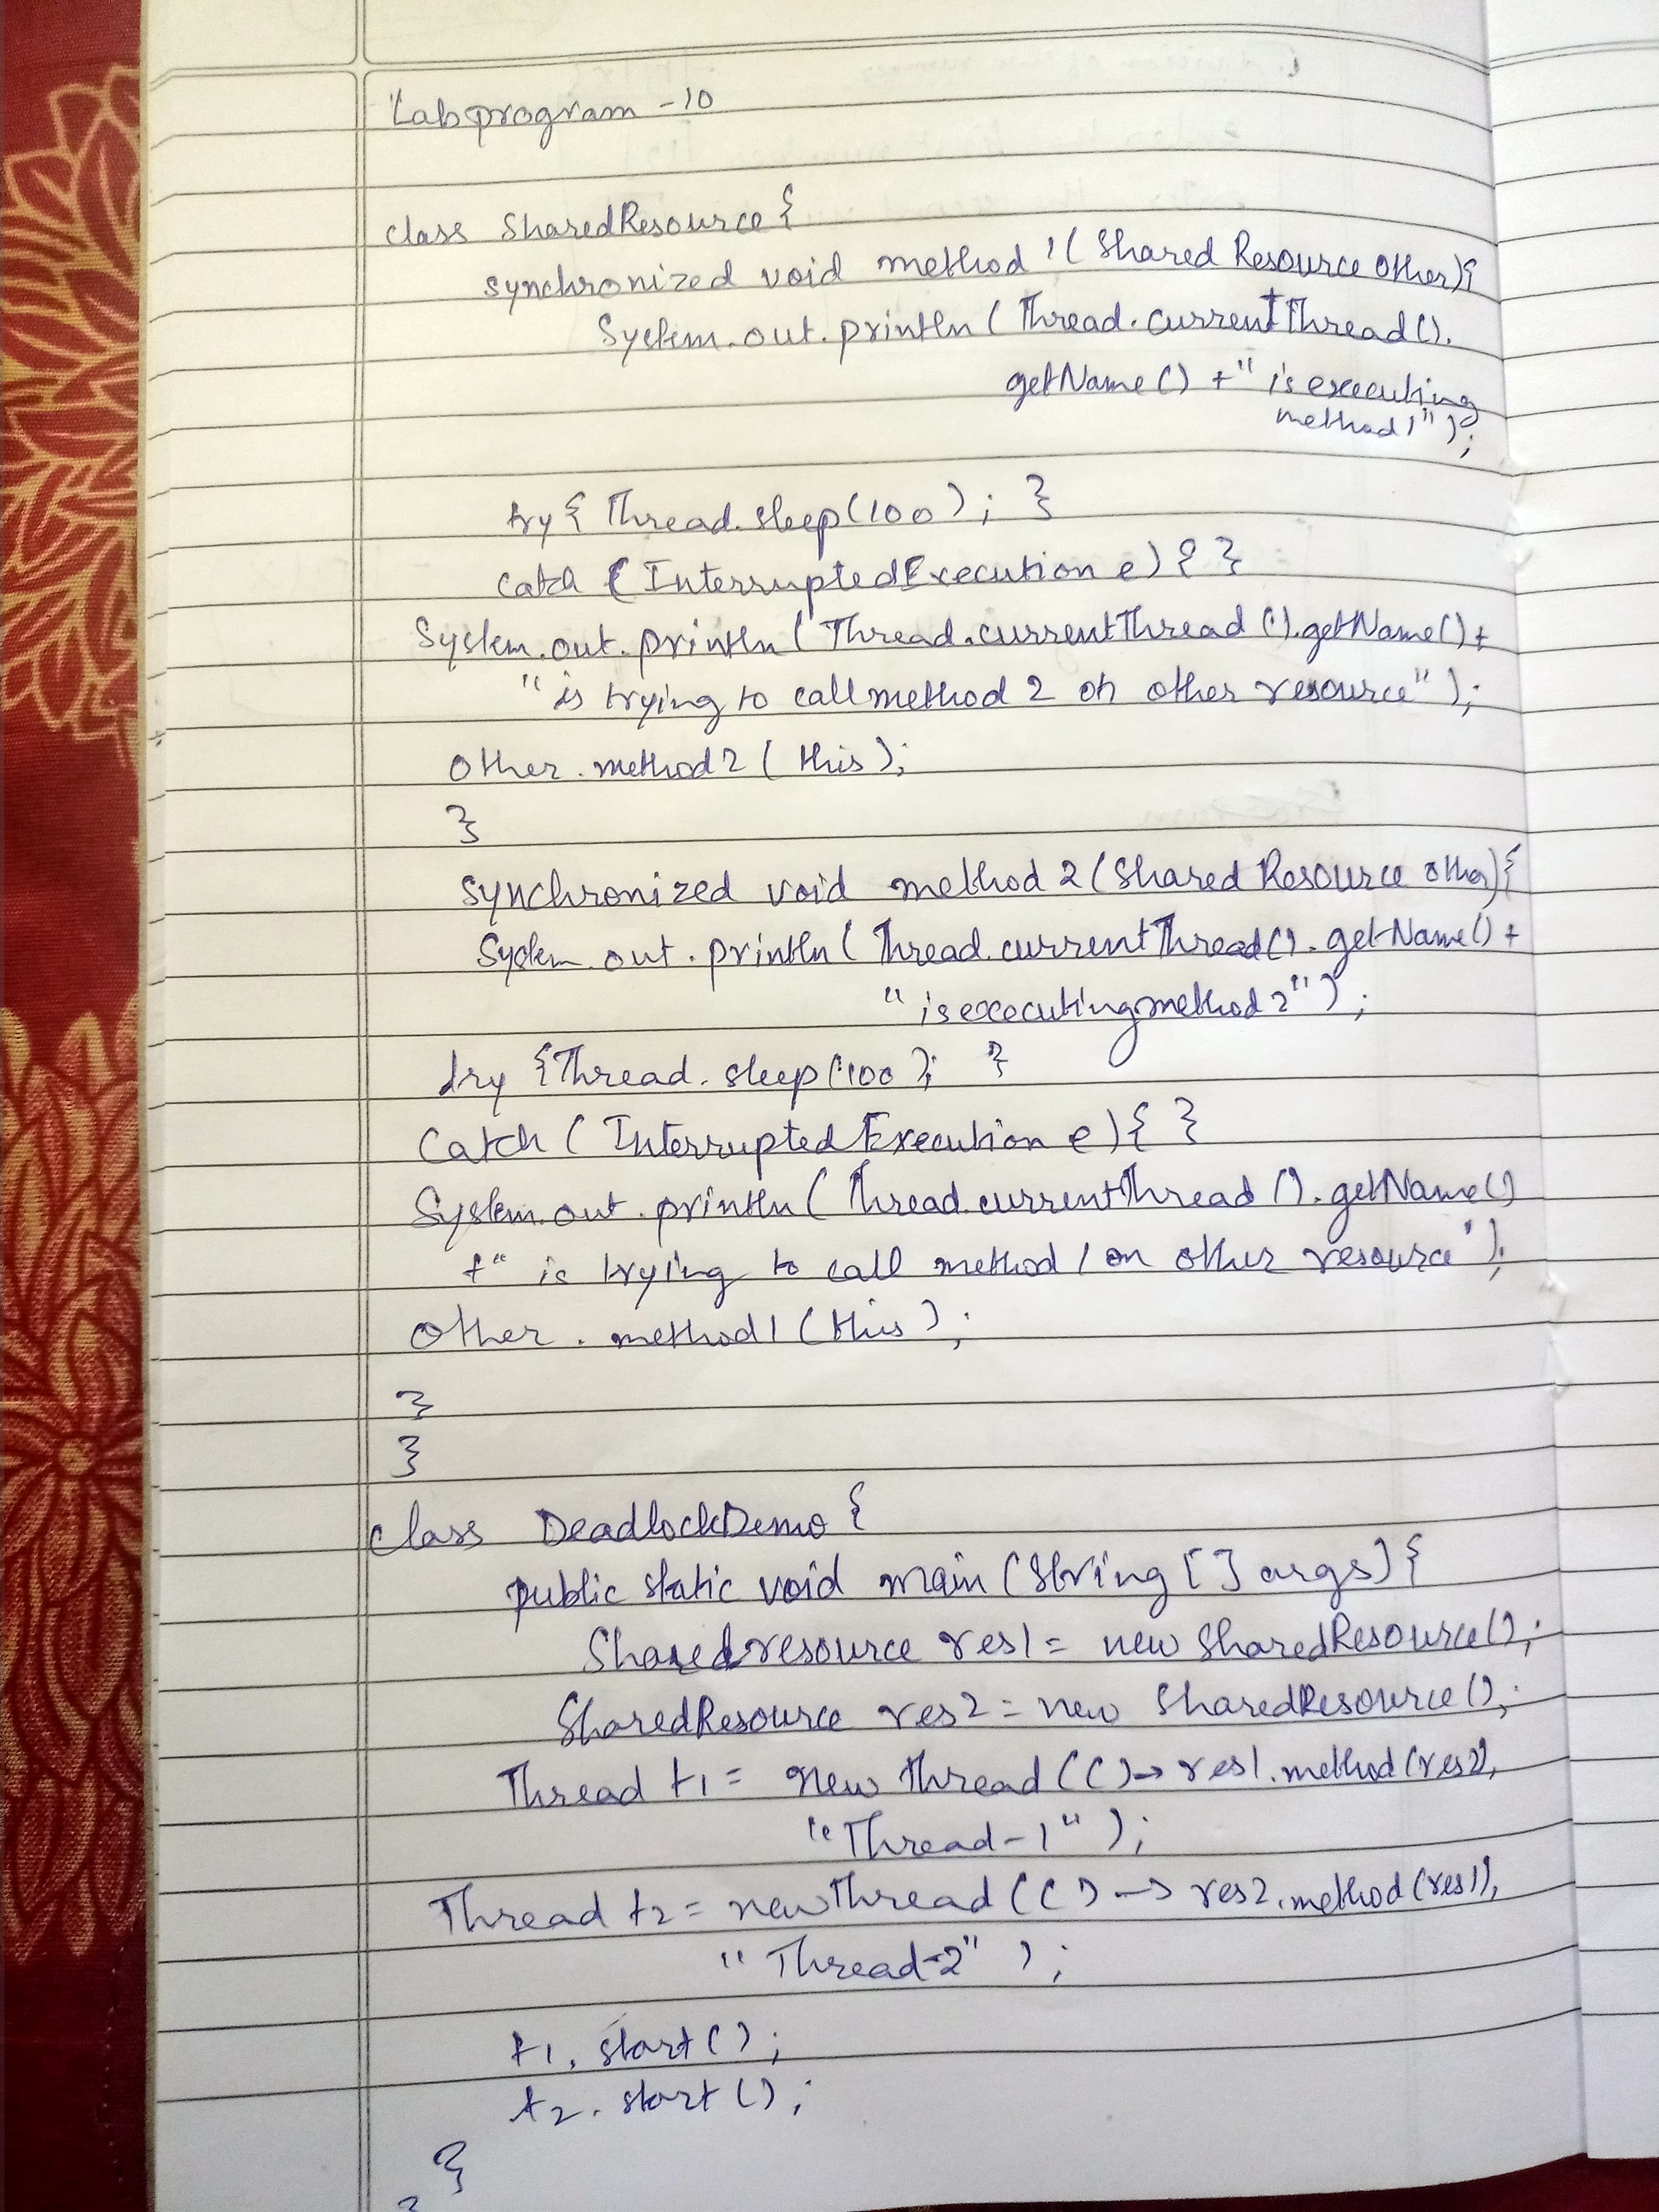

OUTPUT:

Thread-1 is executing method1

Thread-2 is executing method1

Thread-1 is trying to call method2 on other resource

Thread-2 is trying to call method2 on other resource